# Results

## Tissue shape changes in evagination

## A topological method for spatial analysis

The development a of computational method for 3D apical cell shape analysis as an extension of Tissue Miner was done in collaboration with Joris Paijmans, Charlie Duclut and Marko Popović. The code relevant for this thesis and individual contributions are indicated in the Materials and Methods.

### Extracting cell shape information for curved surfaces

The observed inhomogeneity of tissue shape changes necessitates spatial-temporal mapping of cell and tissue properties over development. Typically, such an approach would involve 4D live imaging of a developmental time series and tracking of cell and tissue movements (Etournay et al., 2016). However, although it is possible to live image wing disc eversion *ex vivo* in a tissue culture system, such an approach comes with limitations for full 3D live imaging, potential side effects of culturing, and effects on tissue shape due to external confinement necessary for imaging (Aldaz et al., 2010; Dye et al., 2017) Figure 1‑3.

Supplementary movie XXX.

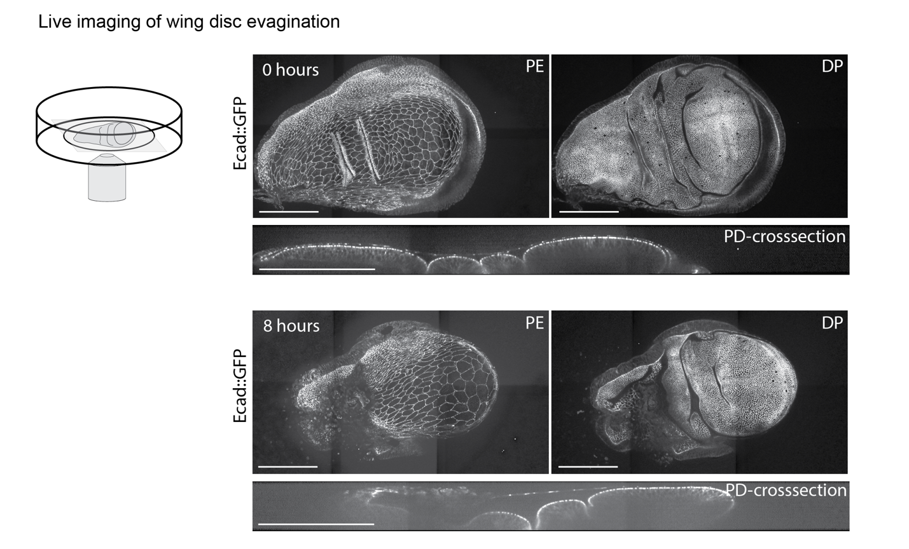

Figure ‑| Confocal live imaging provides only partial information on cell and tissue shape

Wing disc eversion in culture in combination with spinning disc confocal live imaging. Wing discs are dissected and mounted at wL3 stage; culture medium contains 400nM of 20E for eversion. Snapshots show apical surface projection of DP and PE and a crosssection view along the PD axis. Images show 0 and 8 hours of imaging, of a 14 hours movie with 5 min intervals. Scale bars = 100µm, signal = Ecadherin::GFP

Given these limitations, I decided to explore the static, but full 3D dataset we use for tissue shape description that allowed *in vivo* development until the time of imaging. In order to get cell shape information, I project the apical surface of the DP and segment cell shapes in the wing pouch as described previously (Aigouy et al., 2016; Dye et al., 2017). Note that for pupal stages we segment cell shapes on each imaging angle separately instead of using a full 3D multiangle fusion approach as we do for tissue shape analysis. This is necessary as multi‑angle imaging takes 2-5 minutes and during that time period the tissue moves slightly and cell shapes fluctuate which impacts on the image resolution and the ability to segment cell shapes in multi‑angle reconstructed images. Moreover, cell shapes are segmented on a 2D projection, thus cells shape in highly folded regions is not resolvable (Dye et al., 2017).

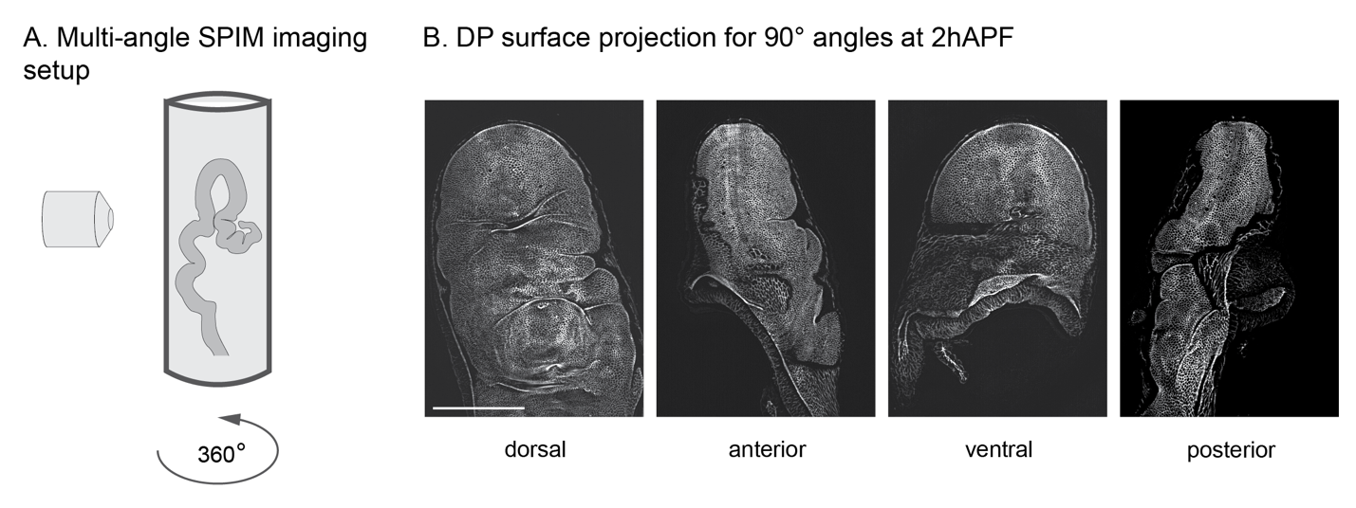

Figure ‑ Multi-angle SPIM setup captures the tissue surface except for folded regions

Schematics, showing the imaging setup for live wing discs in 1% low melting agarose. The agarose column is rotated for multi-angle imaging (A). DP surface projections for dorsal, ventral and lateral imaging angles on a 2 hAPF wing disc. Scale bar = 100 µm

Next, I extract cell shape information from the segmentation mask and use the height maps from the surface projection to gain 3D position of cell vertices (Figure 1‑5 A). This method has been developed in collaboration with Joris Paijmans and takes tissue curvature into account. This advances the previously established 2D analysis of cell and tissue shape, generating a curved surface description of tissue shape. This method is generally applicable to any curved surface analysis, if heightmaps generated from the 2D projection of the segmented tissue are available.

### Establishing topological coordinate systems

To spatially map different regions in the tissue I make use of morphological landmarks and compartment boundaries that are identifiable by E‑cadherin::eGFP (E‑cad::eGFP) on apical cell junctions. Morphological landmarks that are easy to define throughout growth and evagination are the dorsal and ventral half of the wing blade, the DV‑boundary, the PD‑axis and often the AP-axis (Figure 1‑1 C). Other well established morphological landmarks involve the future wing veins, the AP‑boundary or the dorsal sensory organ precursors, however none of these are identifiable on apical cell morphology throughout all evagination stages.

Previous analysis of cell shapes in the wing disc have revealed a radial pattern of cellular properties that is centered at the distal tip of the pouch (Dye et al., 2021). Together with the fact that there are no cell flows across the DV‑boundary, this makes the distal tip a suitable candidate for orienting a regional analysis of cell and tissue shape changes. Another such candidate could be the DV‑boundary itself, which has however more complex changes in the spatial coordinates over time.

In order to achieve a spatial binning by a polar coordinate system around the distal tip, I use a spatial binning method based on the topological distance in the tissue. Here, the unit of distance is the number of cells on the shortest path between two points, where the path connects through shared bonds between cells, or in other words – cell neighbors (Figure 1‑5 B, C).

This has the advantage, as compared to metric distance, that it is independent of 3D tissue shape. Moreover, A topological method is robust to cell shape changes as they do not directly affect the neighborhood relationship in the Tissue. Yet, it is still sensitive to topological changes, such as cell rearrangements, death or division.

During wing disc growth, cell rearrangements occur approximately at a rate of 1.0 cell−1hr−1. If the rearrangement frequency is similar though subsequent stages, per time interval of 2 hr (our analysis), cells would remain within 0-2 cells distance from their original cellular neighborhood. Another aspect that can change the topological position are cell death and cell division, yet as the wing disc enters a phase of growth arrest at late larval stages, we assume for the analysis of evagination, that those contributions do not lead to a dramatic change in topology or cell number. For the analysis of cell shape change during growth this assumption does not hold true. However, the growth process has been studied previously in detail and the focus of this work lies on the studies of evagination. Growth stages will only be included for completeness, when necessary to understand subsequent morphogenesis.

In order to establish polar coordinates, the tissue center of the wing disc needs to be identified. As indicated above, different morphological landmarks are suitable spatial analysis. Moreover, the wing pouch can be morphologically subdivided into 2 main regions: the DV-boundary and the pouch outside the DV‑boundary. The DV‑boundary, a mechanically and morphologically distinct long stripe of cells, that bends during morphogenesis along its long axis, but remains rather flat along its short axis. The DV‑boundary is subdividing the dorsal and ventral half of the wing pouch, which start out as two halves of a hemispherical cap at larval stages and flatten successively.

Each of those regions gets assigned a center, from which a topological spatial coordinate system is established. As dorsal and ventral side of the pouch are imaged in different views, I define the tissue center for dorsal and ventral half separately. Thereafter, dorsal and ventral half are considered symmetrical and cell and tissue shape properties are averaged over both sides. This is motivated by the observation that tissue curvature changes along both sides are similar, thus any properties that contribute to shape should be observed in both regions simultaneously and a merge of these regions reduces analysis noise. Dorsal and ventral pouch combined will be called outDV region hereafter.

As the tissue center is not identifiable unambiguously by eye, for dorsal and ventral pouch regions, first the cells at the edge of the segmentation mask that are facing the HP‑fold are identified (margin region) Next, the shortest topological distance to the margin for every cell in the tissue is calculated (Figure 1‑5 B).This results in a spatial binning that is non‑radial and depends on the segmented region and the margin shape but it identifies the cells furthest away from the margin (at maximum *k* ), which are then used to define one center cell. The identified center cell is used initiate the radial topological distance metric, leading to a radial spatial binning by *k* (Figure 1‑5 C and D). In relation to the polar coordinate system, the radius r, is resembled by topological distance *k* , and the angle φ is orthogonal to r. Cells within the same topological distance to the center (topological ring) have the same r but different φ.

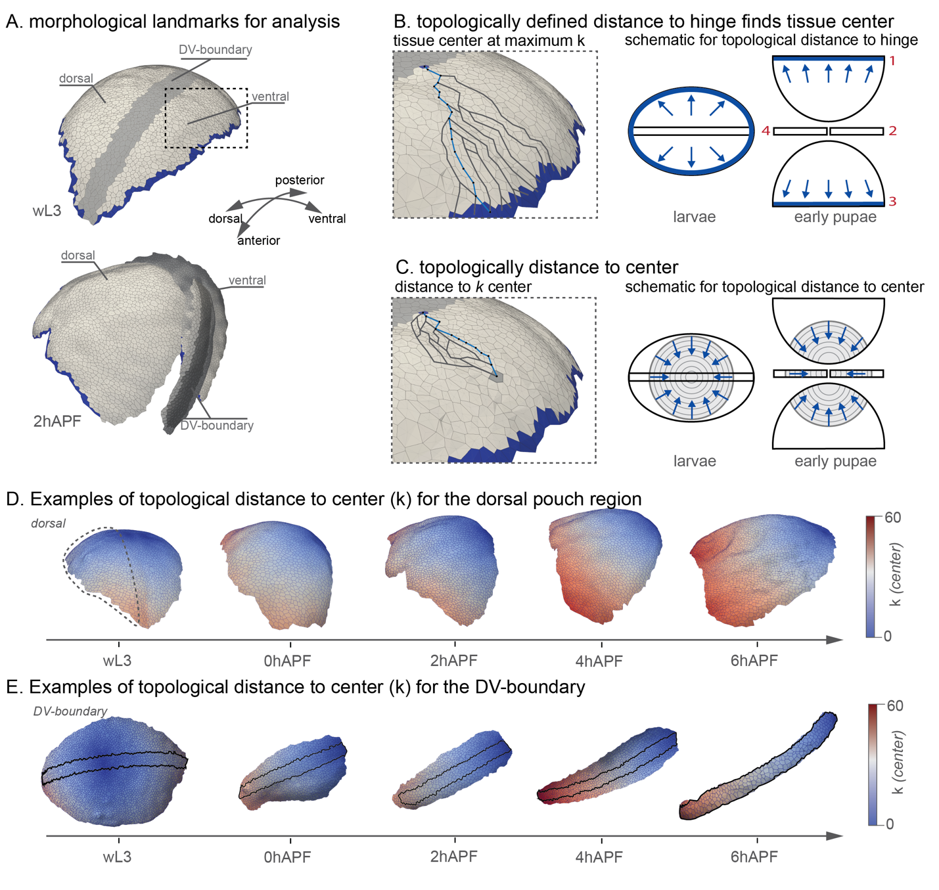

Figure ‑| A topological method for spatial analysis

3D visualization of a segmented larval (wL3) and early pupal (2 hAPF) wing pouch. The larval pouch can be segmented in one view, as dorsal and ventral and DV‑boundary live in the same plane, the pupal pouch is segmented in 4 views due to its double-layer structure. Morphological landmarks can be identified by eye. The region, facing the HP-fold is given by Tissue Miner (margin cells) without an overlay with DV-boundary neighbors (A). We find for each cell in the tissue its shortest topological distance to the margin (B). To do so, paths to all margin cells are calculated. One cell can have multiple equally shortest paths. We show examples of a few potential topological paths and highlight the shortest in blue (B). The shape of the so- generated topological bins method highly depends on the tissue outline. To get to a radial approximation, we find the center with the longest topological path to the HP‑fold, and count the reverse, the shortest topological path to the center. We highlight in blue the shortest path to the center from an arbitrary chosen cell in the tissue (C). D and E show examples of this spatial topological distance (k), for the dorsal tissue and the DV‑boundary for developmental stages over evagination.

For the DV boundary a slightly different approach is used, as the DV boundary is only a few cells wide and resembles more a cartesian geometry with the x-axis along, and the y-axis across the DV‑boundary. (Figure 1‑5 E). To approximate a cartesian geometry, a stripe of cells is defined as center. This is defined for larval stages as the DV‑boundary cells between *k* =0 for dorsal and ventral and for pupal stages by the cells facing the tissue margin distally. (MM)

Taken together, wing disc evagination presents 4 different analysis challenges: larval and pupal stages, that are inherently different on the number of images necessary to get the full pouch shape, and the different regions, DV-boundary and the outDV region, follow different geometrical logic.

For comparability between timepoints we further apply a set of rules that defines a region tracked by topological distance to the center (Figure 1‑6).

1. The number of cells for analysis is given by the number of cells in the wL3 stage and is contained for subsequent timepoints.
2. Topological bins cannot be discontinuous
3. Center cells for dorsal and ventral half of the outDV region are defined by the maximum distance to the margin region. The margin region is defined for larval stages to be the cells at the edge of the segmentation mask, excluding cells from the DV-boundary. For pupal stages, as the DV‑boundary is not in view, I exclude those cells next to the DV-boundary.
4. The center cells for the DV-boundary at larval stages are given by their metric position in the disc. Lying on a path between the center cells of the dorsal and ventral half.
5. Center cells for the DV-boundary at pupal stages are given by tissue orientation, overlap with the tissue margin and the DV-boundary.

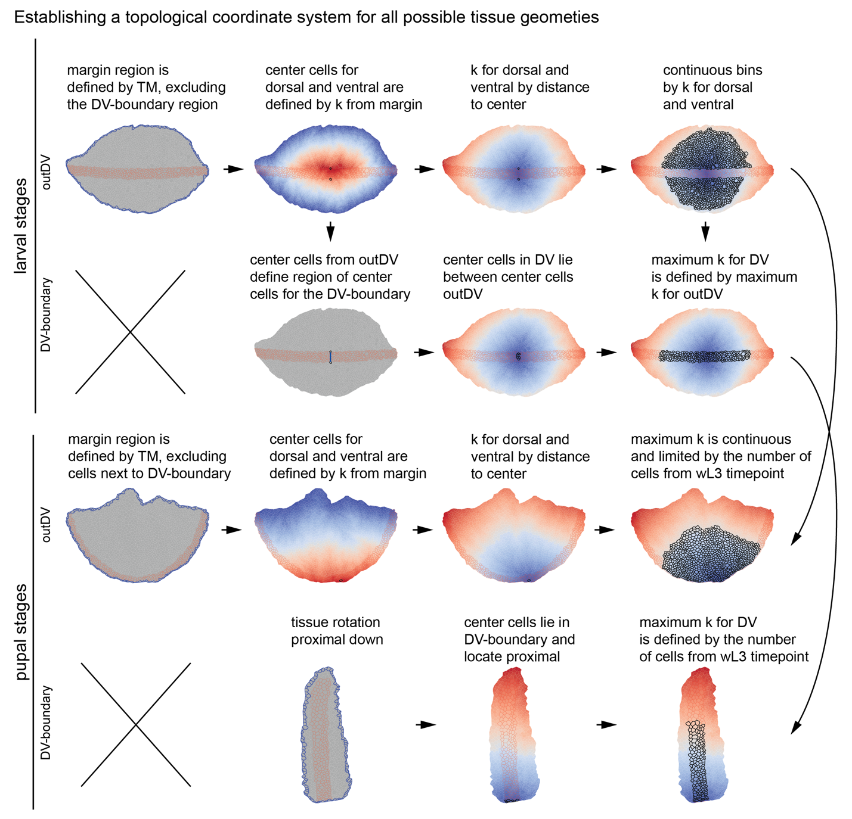

Figure ‑| Overview of topological coordinates workflow

We present the workflow for on exemplary images for larval (wL30 and pupal (2 hAPF) stages. *k* distance is indicated by cell color from in blue to red. blue = small *k* , red = large *k* . Cell bonds of cells from the margin region are outlined in blue, cell bonds from cells in the DV-boundary (for larva: outDV, DV-boundary and pupa: DV‑boundary views) or next to the DV‑boundary (pupa: outDV region) are outlined in red. Center cells are highlighted in black for the second and third column and all cells included in the analysis are highlighted in black for the fourth column.

Using the topological distance method, cells with the same topological distance to the center can be coarse grained into one bin, this leads to a 1D description by distance, but not by the second coordinate axis, which represents the width (or the y-axis) in case of the DV‑boundary or the angle (*φ*) for the outDV region. I make this assumption since a radial dependency of cell properties has been demonstrated before and I am following a coarse-grained approach by comparing developmental stages that are relatively far apart. However, a second topological distance can be introduced, when necessary, to generate a 2D coordinate system and unambiguous spatial topological coordinates for each cell. The advantage of a topological coordinate system as compared to a metric system is its versatility, and tissue shape and curvature independence. Moreover, we can use it as a tool to establish topological distance and cell number based relationships between different timepoints.

### Spatio-temporal mapping of cells and tissue shape by topological relationships

The relationships of topological distances between timepoints were established in collaboration with Abhijeet Krishna

Topological binning reveals that I segment larger tissue areas with increasing topological distances from the center during eversion, which can be explained by those cells that were previously hidden in the HP‑fold coming into view as the fold opens up. To understand tissue and cell shape changes during eversion, analysis needs to be limited on the region that is visible over all timepoints and has not been hidden in the folds at larval stages. Moreover, as I use radial binning, and average out angular effects, only those topological bins that are uninterrupted along their tangential axis, within the outDV region, can be included in order to be consistent on the effect of averaging. This excludes the outermost topological rings that intersect with the fold region. We then use the cumulative number of cells from the reference timepoint wL3 to identify the matching regions at later stages based on the number of cells (Figure 1‑6). In order to keep the number of cells constant, the maximum topological distance must increase from 21 to 24 in the outDV region and from 21 to 37 in the DV boundary (Figure 1‑7 A). These changes can be explained by changes in tissue topology, such as cell rearrangements, during eversion. Although the unit of measurement for *k* is the number of cells, the path length, connecting cell centers, can be calculated in µm distance. This calculation reveals, that within the same topological distance, the metric (µm) distance from the center increases during eversion and expansion. revealing that on top of topological changes, cell shape changes are happening during both processes (Figure 1‑7 C). To be able to spatially compare cell shapes between discs of different stages, we use the relationship between topological distance k and cumulative cell number N(k) (Figure 1-7). Cells in a ring *kinitial* of the reference timepoint can be identified by the cells between cumulative cell numbers N(*kinitial*) and N(*kinitial* - 1). This group of cells should be compared to those *kfinal* rings in the disc of the final timepoint which contain cumulative cell numbers between N(*kinitial*) and N(*kinitial* - 1). As shown in the schematic (Figure 1-7 C), these cells can be contained in multiple and fractional rings in the final timepoint. We refer to these *kfinal* rings by Kref which refers to the *kinitial* ring of the reference timepoint.

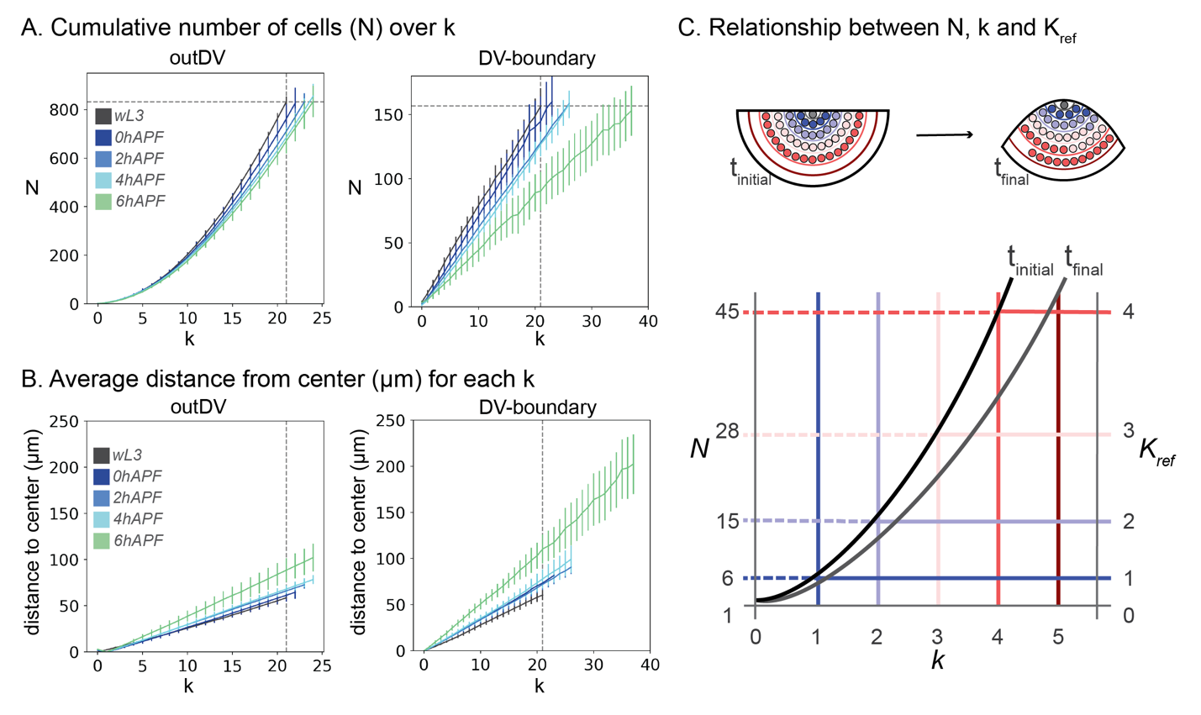

Figure ‑| Comparing topological coordinates between timepoints

Analysis of the relationship between *k*, the cumulative number of cells (N) and distance in µm. As *k* increases, the number of cells contained up to k also increase (A). We calculate the distance to *k* =0 for each cell and average by topological bin (B). DV-boundary and outDV are plotted separately, different developmental stages are indicated by color, the vertical dashed line shows the average *N* at maximum *k* for wL3, the horizontal dashed line shows maximum *k* for wL3 in the respective region. Error bars indicate the 95% confidence interval of the mean (A, C). The relationship between *N* and *k* is given for each timepoint. To compare spatial properties between timepoints we set *Kref* based on *N(k)* of the initial, or reference timepoint and use a *Kref* based spatial binning which consists of a weighted average of *k* by *N(initial)* for the final timepoint. For the initial timepoint, *N(k = 3)* = 28 cells and *Kref* *= k*, for the final timepoint, we keep *N* = 28, yet to achieve this number of cells we are including a half of the next topological bin (*k4*) and *Kref* = *k3* + ½ *k4*

### Applying spatial information to tissue shape analysis

Until now I analyzed tissue shape and curvature changes on the full pouch region. Yet in order to understand the interplay between cell and tissue shape changes, the analysis needs to be focused on the region of the pouch, where I have information on cell shapes over all timepoints. As seen above the topologically defined region can also be measured by distance in µm from the tissue center. Using this metric distance approximation for topological tissue patches, the tissue shape analysis can be refined to a region where I obtained cell shape information throughout all developmental stages (Figure 1‑8 A).

Here I need to make a methodological distinction between growth and evagination stages: For evagination stages (wL3 to 6 hAPF) I use the average distance at maximum *Kref* to compare tissue shape changes over developmental time. As this *Kref* is only valid for developmental processes with no net growth, it cannot be used for comparison between larval stages, when the tissue is still growing. Yet, previous analysis during wing disc growth at 96hAEL has shown that tissue growth and cell divisions are homogeneous throughout the pouch (Dye et al., 2021). As cell shapes are only segmented in the homogeneously growing region of the pouch, this region can be used for comparative analysis. Thus, for growth stages, a comparison over the segmented region without restrictions on cell number and topological distance is reasonable. Under this assumption, I use the maximum distance at the respective maximum *k* for all timepoints to define the region along the tissue shape that is contained by cell shape analysis.

I observed, that that the topologically tracked region only constitutes a small part of the pouch region. This is on one hand due to our rigorous exclusion of discontinuous topological bins at the larval stages, and on the other hand indicates a big contribution by cells derived from the HP-fold during evagination stages (Figure 1‑8 A). A region that I cannot segment during larval stages, thus needs to be excluded from the analysis.

For the subsequent analysis, and in the region we analyze, the three main developmental processes are characterized as follows (Figure 1‑8 B,C):

At the transition from larval growth to wL3 stage, the top of the pouch becomes increasingly dome shaped. The curvature remains higher along the PD-axis towards the folds. The curvature at the wL3 stage is spatially homogenous along the DV‑axis, resembling a spherical cap. Along the PD‑axis the curvature in the center matches the one in the DV‑axis but it becomes more curved towards the periphery.

At eversion, the curvature increases dramatically at the center of the PD‑crosssection, which corresponds the tissue region close to, and across, the DV‑boundary. The curvature increase along the DV‑boundary is more subtle.

At expansion, the curvature increased even further across the DV‑boundary, and we do not observe changes along the DV‑boundary.

Some of the features observed on the full pouch shape analysis will not be immediately addressed, as they lie outside the topologically defined region. Yet they offer interesting questions on tissue morphogenesis:

For late eversion and expansion stages, the pouch reached zero curvature on the outDV region, this regime is outside the topologically confined region and I will not further consider it in this analysis. Nevertheless, cell shape information for this region is available and might offer information on the transition form of curved to flat epithelial sheets.

Moreover, the high tissue curvature for larval stages, at the beginning of the folds, is not covered by the topologically defined region. The folds in larval stages could lead to interesting observations on cell packing geometry, on a small radius of curvature for apical-outwards bent tissues.

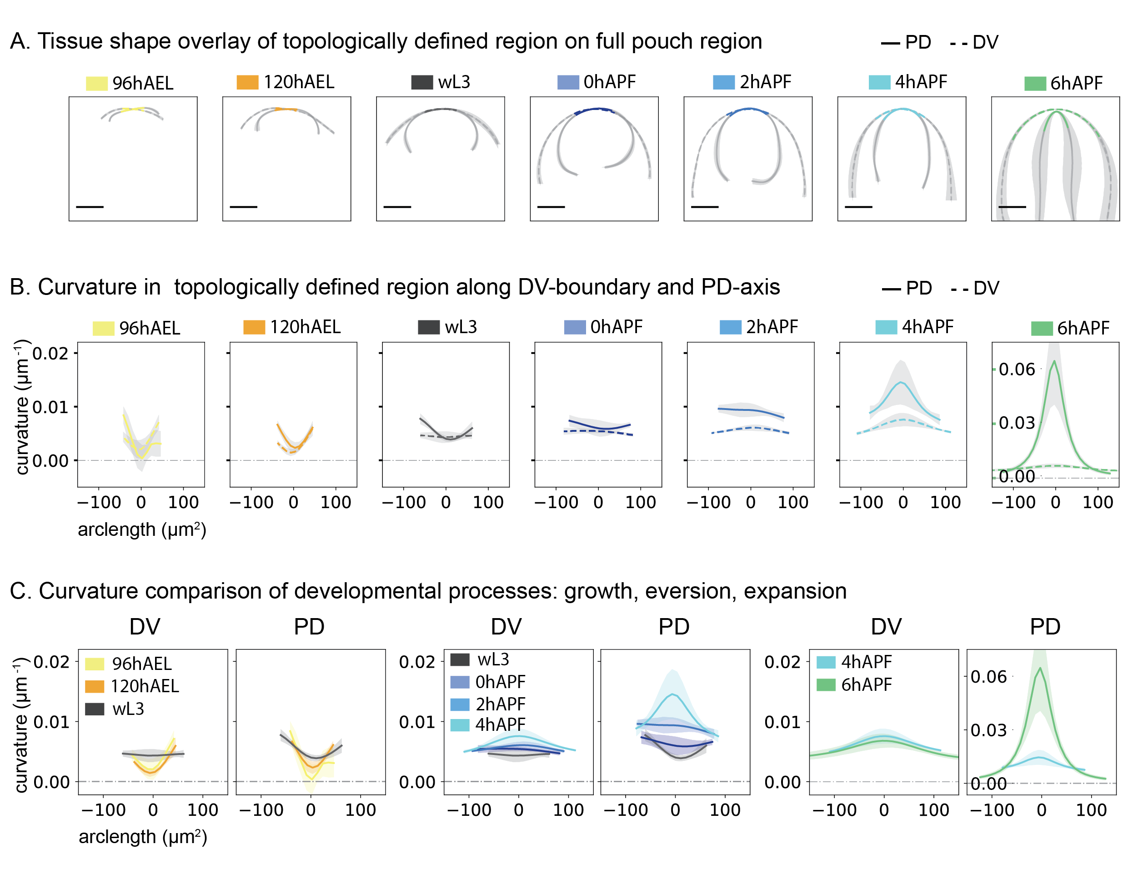

Figure ‑| Spatio-temporal analysis of curvature changes by topological region.

Tissue shape overlay of the topologically defined region with the full pouch shape along DV and PD‑axis for developmental stages 96hAEL, 120hAEL, wL3, 0 ,2 ,4 and 6 hAPF. DV = dashed line, PD = solid line. Mean shape curves for all stages and all discs analyzed along DV‑ and PD‑axis, grey region indicates the 95% confidence interval of the mean for x and y position (A). Curvature quantification in topologically defined region along the apical shape by arclength, grey region indicates the 95% confidence interval of the mean for the curvature, y-axis is indicated on the left for all stages except 6 hAPF, where the y-axis is indicated on the plot (D). Tissue curvature changes for DV and PD‑axis, over developmental processes: growth (96hAEL, 120hAEL, wL3), eversion (wL3, 0 ,2 ,4 hAPF) and expansion (4 and 6 hAPF). Shaded region 95% confidence interval of the mean in the color of the respective developmental stage. Y-axis are the same between DV and PD for growth and eversion (C). Scalebars = 100µm

### Topological binning reproduces previous results on larval stages

The topological distance method and the definition of the tissue center constitutes a coarse-grained approach to understand cell packing patterns. Different aspects average out more subtle effects of radial cell packing patterns. Most importantly, the definition of the tissue center is susceptible to a certain amount of noise, and topological bins are, as a consequence of cell shape heterogeneity, not perfectly circular.

To understand the significance of these effects, I tested whether the topological method can recapitulate the published cell packing patterns. To test consistency, I compare 96 hAEL and 120 hAEL timepoints with the published data from Dye, Popović et al., 2021. The published data covers a developmental time from 96 hAEL + 13 hr in culture and throughout this time period, no changes in the pattern of cell morphology has been observed. Thus, if the topological method is able to reproduce previous results, the values for the 96 hAEL timepoint should correspond to those published. Moreover the 120 hAEL should add more information on the changes between day four and five of development.

I do not observe changes in the cell area profile between 96 and 120 hAEL, using the topological method (Figure 1‑9 A). To compare this data to the published results, the metric distance to the topologically defined tissue center for each cell is calculated. This confirms that the new data is in accordance with the previously published area profile in both regions and timepoints (Figure 1‑9 A, B). Dye, Popović et al., report also a radial gradient of tangential cell elongation based on radial projection *Qrr* of the cell elongation tensor. I observe a similar elongation profile for 96 hAEL, but at 120 hAEL the gradient of tangential cell elongation decreases, revealing temporal changes in the cell elongation pattern. This, gradual decrease in cell elongation towards the end of larval growth has been previously observed (Mao et al., 2013) (Figure 1‑9 C). Applying the same comparison to the DV-boundary, I find that the elongation profile along the DV‑boundary (*Qxx*) is in accordance with previous results: Cells are elongated along the direction of the DV‑boundary without a spatial gradient (Figure 1‑9 D).

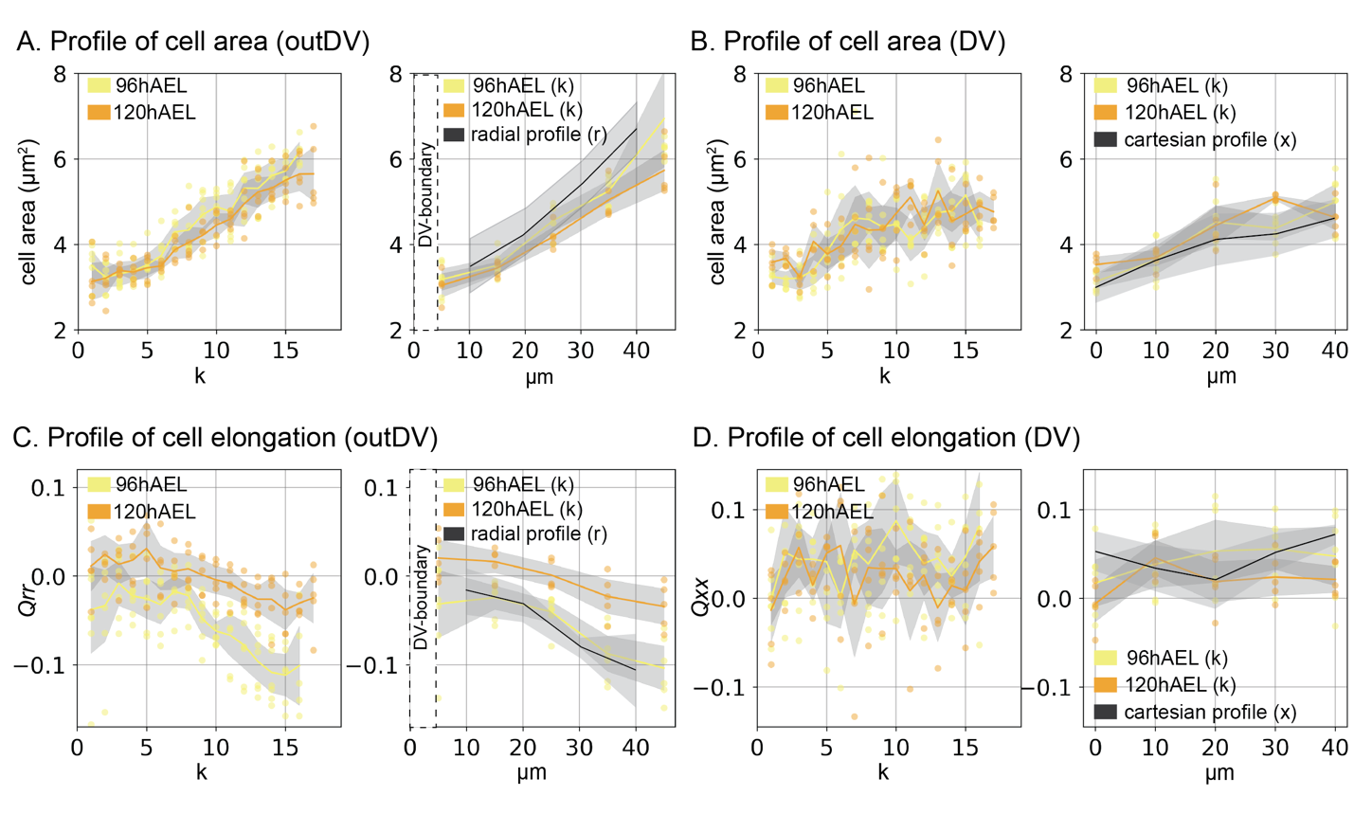

Figure ‑| Topological binning method reproduces previous results

Datapoints show the mean values per disc and for each spatial distance for cell area (A,B, outDV and DV regions) and the radial component of cell elongation (*Qrr*) (outDV, C) and the xx component of cell elongation (*Qxx*) (DV, D) For spatial plots in metric distance (µm) we use a similar coarse graining to the one previously published, with the exception, that for the outDV region, we exclude only the DV-boundary and not a 10µm wide region around the DV-boundary as done previously. We round to nearest intervals of 10µm and display the average value for each disc analyzed. Colors represent developmental stages; lines present the average from all datapoints. The grey region around the 96 and 120 hAEL stages shows the 95% confidence interval of the mean. Radial and cartesian profiles are taken from Dye, Popović et al., 2021. For this dataset the shaded region shows the standard deviation.

### Summary topological method for spatial analysis

Overall, the new method presented here can recapitulate previously described patterns in packing geometry, and can approximate radial and cartesian coordinates by topology. The topological binning method is applicable for any tissue geometry and allows for different parameters depending on the tissue geometry and morphological landmarks. We also establish a methodology to map spatial changes over different developmental timepoints based on *Kref* without the need for live imaging and cell tracking. I have further identified the tissue shape changes that are happening in the topologically defined region, providing the toolset to address cellular contributions to tissue shape changes during wing disc evagination.

## Cell packing geometry during evagination

### Cell shape variability decreases over evagination

To understand how the tissue shape changes are accomplished I investigate the changes in cellular packing geometry at the apical surface, starting with cell area (Figure 1‑10). The tissue wide average of cell areas increases by ~3-fold during eversion and expansion. During the growth phases cell areas do not increase dramatically, although cells in the DV‑boundary are initially smaller than the outDV cells, this difference vanishes at 120hAEL. There are no significant differences between the DV and outDV regions at most stages, except for 96 hAEL. Yet, cell area increase follows different kinetics between different regions during eversion. From 0 to 2 hAPF cell areas increase in the outDV region, but not in the DV boundary, while the opposite is the case from 2 to 4 hAPF. At 4 and 6hAPF, disc-to-disc variability for average cell areas increases. This result could merge from the more dramatic change in area that occurs during this time period, where the wing pouch doubles its apical surface area within 2 hr of development. Importantly, any small variations in developmental staging could have a high impact if changes are rapid in time. This variability in staging was also seen in different progress in PE removal that I observe at 4 hAPF (Figure 1‑10 A,B).

I investigated whether the area variability between discs is mimicked in the area variability within the disc. To test this idea, I calculate the coefficient of variation for cell area in each disc as a measure for inter-tissue variability of cell shapes:

$CV= \frac{σ}{μ}$ with $μ=\frac{\sum{a}}{N}$ and $σ=\sqrt{\frac{{∑(ai-μ)}^{2}}{N}}$

Where *a* is the cell area, and N the number of cells. I find that the *CV* decreases over growth and eversion outside the DV-boundary and increases slightly at expansion. The *CV* in the DV‑boundary drops at puparium formation and remains constant thereafter (Figure 1‑10 C).

Another property tightly linked with cell area and growth is the number of neighbors per cell. Larger cells tend to have more neighbors, and cell divisions and rearrangements change the polygon distribution locally. Accordingly, fractions for different polygons can be used as a readout for developmental processes and mechanical state of the tissue. In accordance with previous reports for growing epithelia, the fraction of cells with n neighbors (Pn) is highest for hexagons at larval stages (Farhadifar et al., 2007). During late larval growth the fraction of hexagons increases slightly, while 4,7 and 8-sided cells decrease, this is in accordance with the growth rates slowing down at the end of larval development (Figure 1‑10 D-F). During evagination, the fraction of hexagons increases even further up to 50% of all cells in the tissue, while 5,4 and 8-sided polygons decrease and the number of heptagons remains stable (Figure 1‑10 F). This increase in hexagons could be attributed to the lack of dividing cells, the increase in cell areas, or a tissue state transition towards fewer rearrangements and a predominantly elastic behavior.

My data is however in slight disagreement with reports form 96 hAEL and 120 hAEL timepoints, that observe a similar increase in hexagons, yet the fraction of hexagons is even higher for these timepoints as compared to the fraction observed here (Sánchez-Gutiérrez et al., 2013). Potential reasons for this could be variability in developmental timing, or a methodological difference by the cutoff length at which bonds are considered vertices.

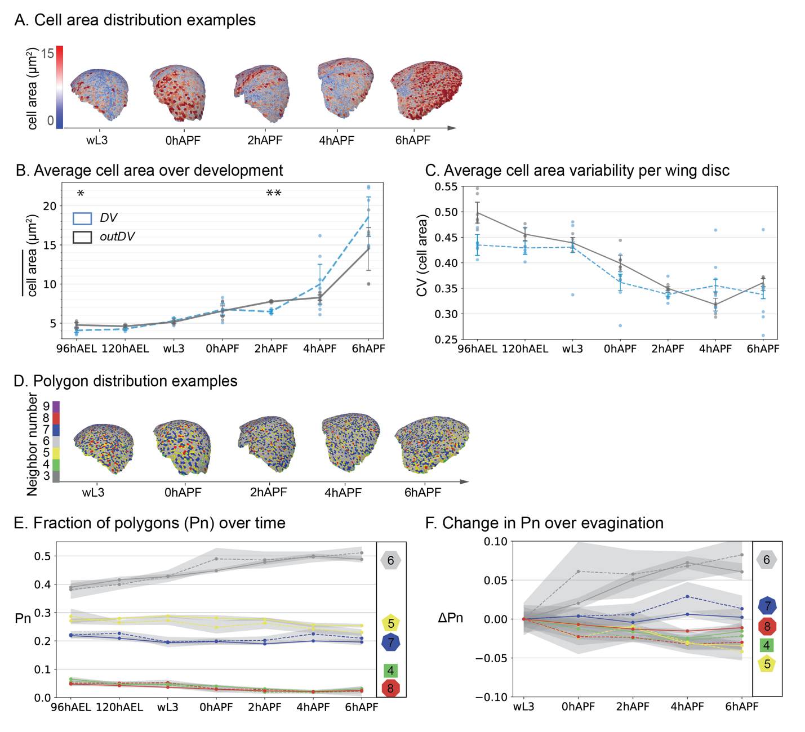

Figure ‑| Cell area and packing topology distributions over evagination

Exemplary images of cell area and polygon distribution in the segmented region, showing the full pouch for wL3 and dorsal side for pupal stages) (A, D). Average cell area and average CV of cell area in the topologically tracked region, black = outDV, blue = DV‑boundary. Datapoints show averages for discs, line shows the average over all discs, error bars show the 95% confidence interval of the mean (B, C). Fraction of Polygons (Pn) in the topologically tracked region. Fractions for polygon classes over development (E) and change in fraction (ΔPn) as compared to wL3 (F). Colors indicate polygon class, dashed line = DV‑boundary, solid line = outDV. Asterisks show statistical significance for the difference in average area between DV and outDV (Mann‑Whitney U, two-sided, method=exact, **: 1.00e-03 < p <= 1.00e-02, *: 1.00e-02 < p <= 5.00e-02. No asterisk: 5.00e-02 < p)

### Spatial patterns of cell area increase during eversion

As seen in the previous chapter, cell areas increase during eversion and at the same time the cell packing geometry becomes more ordered, as the CV of cell area decreases and the fraction of hexagons increase. One mechanism by which these phenomena could be coupled is a differential cell area increase, leading to a more homogenous area pattern throughout the tissue.

Given the previously identified radial organization in the wing pouch, and the relatively simple geometrical implication of polar coordinates radially organized cell behaviors are also a possible candidate for driving morphogenesis. To test, whether radial patterns in cell packing geometry change together with tissue shape changes, I use *Kref* as a spatial metric, allowing for direct comparison of cell shape properties between timepoints by topological position (for reference Figure 1‑7 C).

At wL3 stage, the cell area profile resembles the area profile at larval growth stages, cells in the center are smaller than the periphery. However, the gradient is shallower, with a 1.5‑fold area increase from center to out over the segmented region, as compared to a 2‑fold increase at growth stages. Interestingly, during eversion, this pattern of cell size vanishes and cell size becomes homogenous along *Kref*. This homogenous area distribution is maintained at wing expansion, although cell areas further increase (Figure 1‑11 A, B). In the DV‑boundary, cell areas at wL3 stage are small in the first 5 bins from the center of the wing disc and larger thereafter. This anisotropy in cell area distribution vanishes at 0 hAPF and subsequently cell areas are homogenously distributed along the DV‑boundary (Figure 1‑11 A, D).

Thus far I have compared cell area gradients using the wL3 stage as reference timepoint for *Kref*. Yet, the temporal dynamics of cell area increase are inhomogeneous. To address how this area increase is achieved sequentially, I compare the spatial changes in cell area (A(final)/A(reference)) over *Kref* for consecutive timepoints (Figure 1‑11 C, E). This analysis reveals that, in the outDV region, at the transition from larva to pupa (wL3 to 0 hAPF), cell areas increase by a factor of 1.5 in the center of the disc, and less in the periphery. This in‑homogenous increase is also observed for the transition between 0- 2 hAPF. All subsequent changes are homogenous, yet from 2‑ 4 hAPF, cell areas increase only a little, while at the next timestep from 4‑ 6 hAPF, cells nearly double their areas (Figure 1‑11 C). Interestingly, the temporal dynamics are different in the DV‑boundary: Cells in the DV‑boundary increase from wL3 to 0 hAPF and after 2 hAPF (Figure 1‑11 E). Accordingly, there is a quiescent or reduced phase for cell area expansion at 2- 4 hAPF outside the DV-boundary and at 0‑ 2 hAPF inside the DV-boundary.

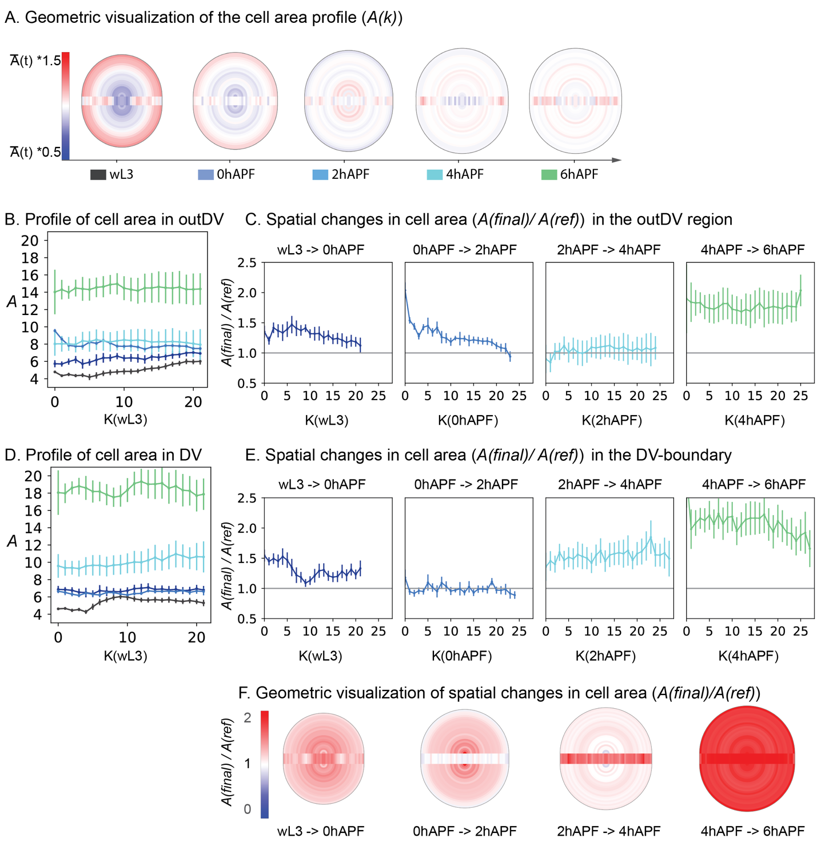

Figure ‑| Changes in cell area profile during evagination

Geometric visualization of the wing pouch over different stages. Each topological bin is colored by its average property from all discs analyzed. Spatial binning in the outDV region is visualized as half-circles; spatial bins of the DV-boundary are visualized by a rectangular box, separating the two sides of the outDV region (A, F). Geometric visualization of cell area distribution. Color code is calculated for each timepoint by the average cell area per timepoint +/- half the average area. Profile of cell area over *K*, where *k*(wL3) is used as reference, for outDV (B) and DV‑boundary region (D). Colors correspond to developmental stages as indicated in A. Spatial profile of consecutive cell area changes (A(final)/A(ref)). Timesteps for each plot are indicated above; colors correspond to the respective final timepoint; *K* is based on *k*(initial) (C, E). Changes in area for outDV (C) and DV‑boundary (E). Geometric visualization of spatial area changes. Color code corresponds to A(final)/A(ref). Values <1 indicate a decrease in cell area (blue), values >1 indicate area increase (red). Geometric visualization is based on *Kref*. consecutive timesteps are indicated below (F)

### Tissue growth during eversion and expansion

To test if the observed area increases are due to a 3D cell shape change or due to cell volume growth, I tested whether they are anticorrelated with the observed height changes and if cell volumes are conserved. I use the height profiles along DV and PD-directions and limit the analysis to the max distance (dmax) observed for each developmental stage based on *Kref*(Figure 1‑12 A.i, B.i). Cells in pseudostratified epithelia experience changes in their cross‑sectional area along their apico‑basal direction. Yet, these effects average out over tissue patches, when a similar packing density is given along the apico‑basal direction. Thus, to estimate cell volume one can assume a cylindrical shape, with the cross‑sectional area given by the apical cell area and *V* = *A*h* where *V* is the Volume, *A* is the apical cell area in µm2 and *h* is the tissue height approximation, given by the smallest distance between the apical and basal DP surfaces. To estimate cell volumes along the PD‑direction, I use a stripe of cells in the tissue center that contains six cells for each topological distance. The cells are defined by the maximum topological distance to the cell next to the DV‑boundary (*k (DV)*) at maximum *k* (so called *k (Edge)* see materials and methods). To estimate cell volumes along the DV‑direction, I use all cells of the DV-boundary up to a length of maximum *k,*as the DV‑boundary is only a few cells wide and the height analysis does not pick up changes along the DV‑width(Figure 1‑12 A., B).

We observe that cell volumes increase slightly along the PD-direction at 2 and 4 hAPF and decrease again at 6 hAPF, but the slope does not change over development (p values > 0.05 for all stages as compared to wL3). Along the DV-boundary, we do not observe significant changes in cell volume, except for a small increase at 6 hAPF (p = 0.017) and we do not observe spatial changes along the DV-boundary (Figure 1‑12 C). These data indicate that cell area expansion and height decrease are anticorrelated during eversion and no differential volume increase is observed, although small, transient changes in cell volume might occur.

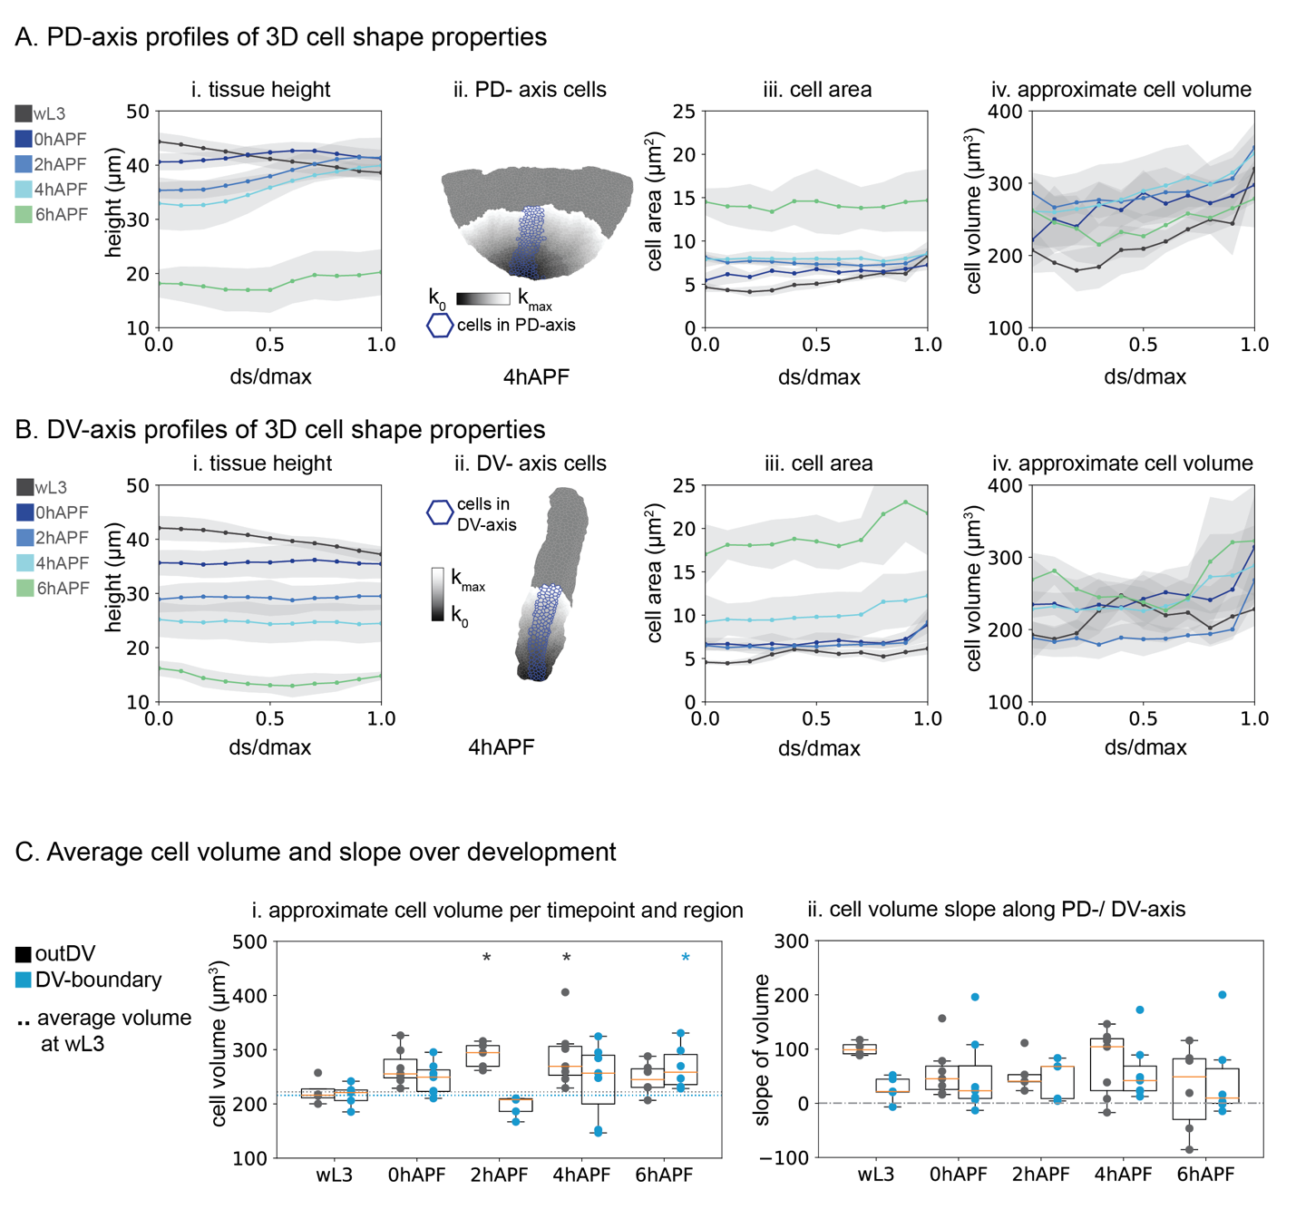

Figure ‑| Tissue height and cell volume changes during evagination

Spatial profiles by a fraction of distance over the maximum distance covered (ds/dmax). ds/dmax is averaged in 0.1 steps, developmental stages are indicated by color, grey region shows 95% confidence of the mean for all wing discs analyzed. One exemplary image of a 4 hAPF wing disc for each direction is shown, outlined are the cells for the respective direction in blue, and *k* is indicated as greyscale (A.ii., B.ii.). Tissue height (i), cell area (iii) and approximate cell volume (iv) are calculated along the PD-axis (A) and the DV‑boundary (B). Average cell volume (C.i.) and slope (C.ii), for outDV in black and DV‑boundary in blue. Each datapoint is one wing disc, boxplots show the median in orange, box shows upper and lower quartile values, whiskers extend 1.5 beyond upper and lower quartile. Dotted line shows the mean for wL3, for each region calculated individually. Dashed line indicates zero slope for comparison (C). Asterisks show statistical significance for each timepoint as compared to wL3 of the same region (Mann‑Whitney U, two-sided, method=exact, *: 1.00e-02 < p <= 5.00e-02. No asterisk: 5.00e-02 < p)

### The magnitude of cell elongation does not change during eversion

As previously observed and confirmed by my analysis cells are elongated tangentially in the growing wing disc at 96 hAEL (see section 1.2.5). But the orientation and magnitude of cell elongation changes towards the end of larval growth (Dye et al., 2017; Mao et al., 2013). Cell elongations can have different implications for tissue geometry and morphogenesis: The magnitude of cell elongation, is a measure for cell shape anisotropy and can indicate mechanical state changes in the tissue (Atia et al., 2018). I observe that towards the end of wing disc growth, the magnitude of cell elongations decreases in DV-boundary and outDV regions. The magnitude of cell elongation does, however not change during subsequent evagination in the outDV region and only transiently increases in the DV‑boundary at 0 and 2 hAPF (Figure 1‑13 A). The spatial pattern of cell elongation does not change in the outDV region during evagination.

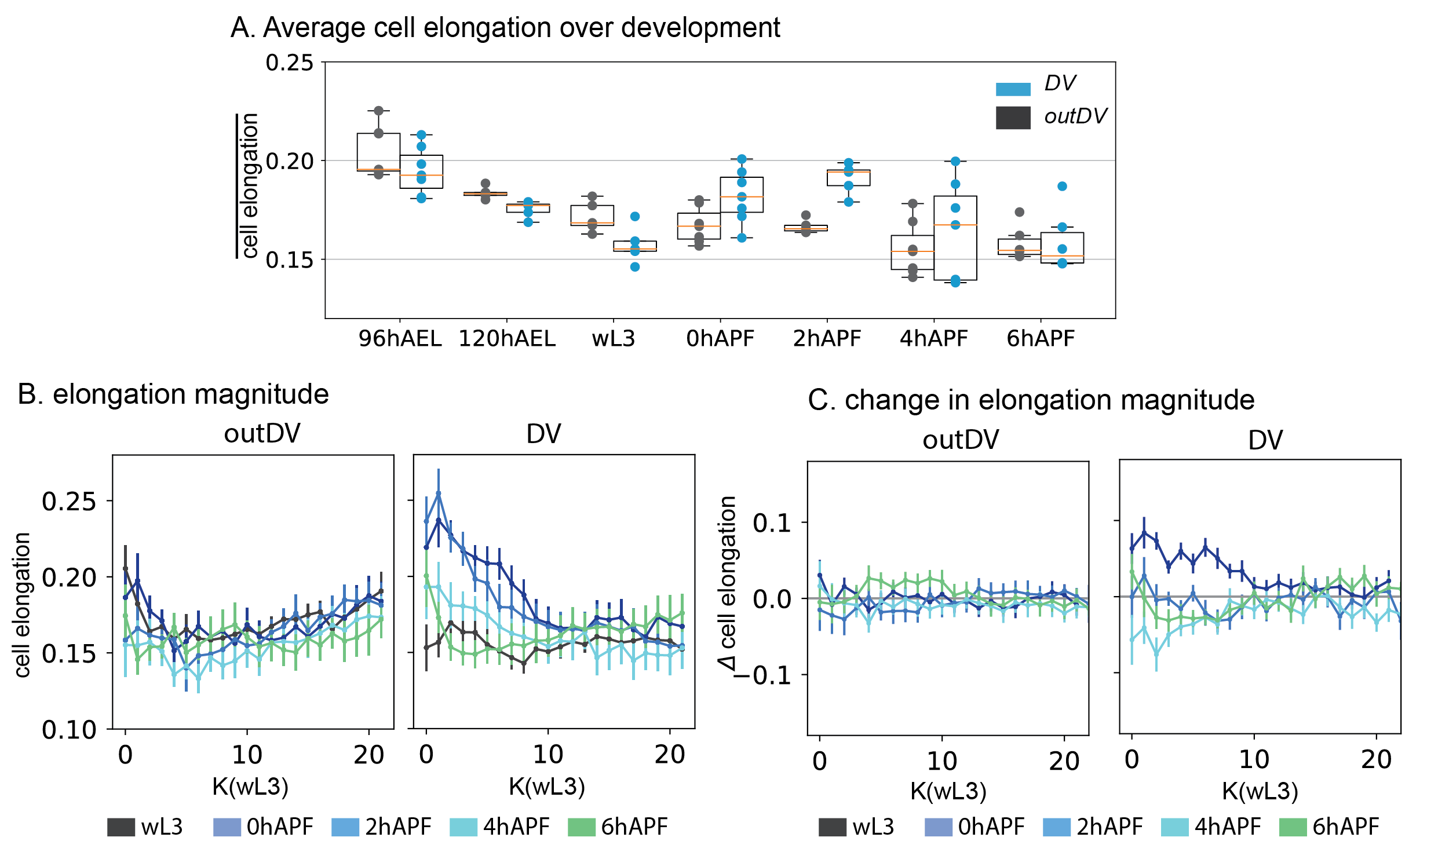

Figure ‑| The magnitude of cell elongation decreases at the end of the growth phase

Average cell elongation magnitude for all disc of a developmental timepoint, each datapoint is the average from one wing disc, boxplots show the median in orange, box shows upper and lower quartile values, whiskers extend 1.5 beyond upper and lower quartile (A). Spatial plots of cell elongation (B) and change in cell elongation (Δ cell elongation) (C) over *K*(wL3). outDV and DV‑boundary are plotted separately; colors correspond to developmental stages (B, C)

This is different in the DV‑boundary, here, during early eversion, cells are transiently more elongated at small k (Figure 1‑13 B). Correspondingly, anisotropic changes in elongation magnitude are observed in at these stages (Figure 1‑13 C).

### Changes in global cell elongation nematic rule out cell elongation as driving force for evagination

Contributions to morphogenesis from cell elongation depend on the orientation of cell elongations. Yet, the magnitude of cell elongation does not contain information on the directionality of the elongated cell. Cellular packing geometry in the wing disc is characterized by a pattern of tangentially elongated cells. A similar elongation pattern has been observed in the leg imaginal disc, and it has been proposed that such a pre-pattern of packing geometry could be resolved to facilitate tissue morphogenesis during leg evagination (Condic et al., 1991). This provides an attractive hypothesis given the more recent observations, that at late growth stages in the wing disc, the cell elongation pattern could be actively generated by rearrangements (Dye et al., 2021). Thus, a prepattern mechanism could provide an explanation for this behavior. To test if this is true, I tested the radial projection *Qrr* and the component of elongation along the DV‑boundary (*Qxx*) of the cell elongation tensor at wL3 to 6 hAPF (Dye et al., 2021). My analysis of 120 hAEL already revealed a shallower gradient and on average slightly radial elongation in the center and more tangential elongation in the periphery, as compared to 96 hAEL (Figure 1‑9 C). This tendency towards a more undirected cell elongation is continued to wL3 stage, where we observe no gradient and no tissue wide orientation of cell elongations in radial or tangential direction ( $Qrr≈0)$ (Figure 1‑14 A, B). This observation rules out a possible contribution of an elongation prepattern in the outDV region for eversion. Over eversion (0-4 hAPF) cells become again elongated tangentially to the center, starting from $Qrr≈0$ in the center to a maximum tangential elongation of $Qrr≈- 0.07$ in the periphery. At tissue expansion (6 hAPF) this gradient of cell elongation has resolved and no orientation of cell elongations are detectable $(Qrr≈0)$ (Figure 1‑14 A, B). The relative changes in elongation reveals that the most dramatic and in‑homogenous change towards tangential elongations outside the DV‑boundary occurs at the transition from wL3 to 0 hAPF. Between 0 to 2 hAPF and 2 to 4 hAPF changes in elongation are uniform, first increasing tangentially then decreasing slightly to become more radial. This trend is continued from 4 to 6 hAPF, with a slightly larger effect in the periphery, regenerating the already described ‘neutral’ elongation profile (Figure 1‑14 C, F).

The orientation of cell elongation in the DV-boundary at wL3 stage is similar to the growth stages and cells continue to be elongated towards the center $(Qxx≈0.05)$ (Figure 1‑14 A, D). Cell elongations are even more elongated towards the center at 0 and 2 hAPF, and become slightly more tangential at 4hAPF ($∆Qxx ≈ -0.1$) and more radial again at expansion (4 to 6 hAPF). (Figure 1‑14 D). Accordingly, the direction of the change in the orientation of cell elongations (*ΔQxx*) changes from initially radial, to tangential at 4 hAPF and radial again at 6 hAPF (Figure 1‑14 E, F).

Taken together, we observe that the orientation of cell elongation changes multiple times during eversion and expansion. In both regions, the sign of $∆Qrr, ∆Qxx$, changes from 2 to 4 hAPF and in the DV‑boundary at the transition from eversion to expansion (4 to 6 hAPF). My analysis rules out an elongation driven eversion process as suggested for the wing disc but indicates a dynamic change in cell shapes that may result from tissue level forces or cellular geometry and topology.

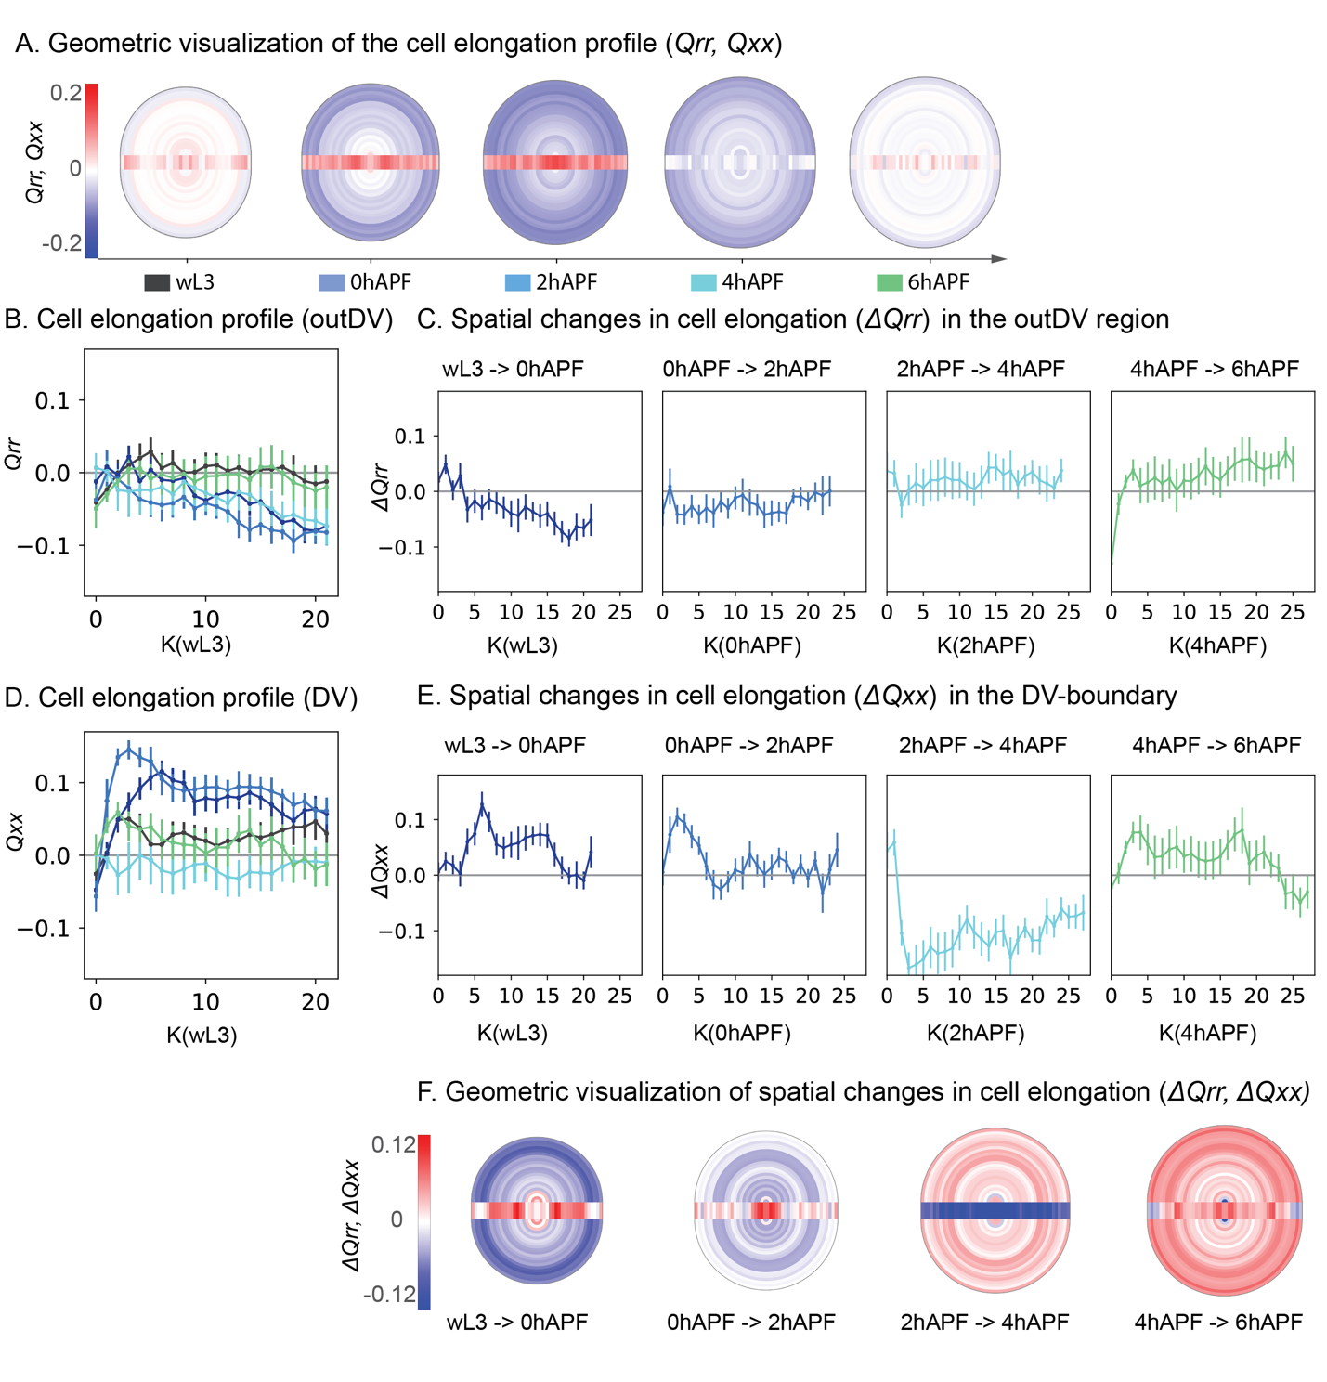

Figure ‑| Changes in cell elongation profile during evagination

Geometric visualization of the wing pouch over different stages. Each topological bin is colored by its average property from all discs analyzed. Spatial binning in the outDV region is visualized as half-circles, spatial bins of the DV-boundary are visualized by a rectangular box, separating the two sides of the outDV region (A, F). Geometric visualization of cell elongation (*Qrr* for outDV*, Qxx* for DV). Color code from -0.2 to 0.2: blue values indicate tangential elongation for outDV and orthogonal to the DV for the DV-boundary, red values indicate radial elongation or along DV-boundary, for outDV and DV respectively (A). Profile of *Qrr/Qxx* over K, where k (wL3) is used as reference, for outDV (B) and DV‑boundary region (D). Colors correspond to developmental stages as indicated in A. Spatial profile of consecutive cell elongation changes *(ΔQrr, ΔQxx).* Timesteps for each plot are indicated above, colors correspond to the respective final timepoint, K is based on *k* (initial) (C, E). Changes in elongation for outDV (C) and DV‑boundary (E). Geometric visualization of spatial elongation changes. Color code corresponds to *(ΔQrr, ΔQxx)*. Values greater then zero indicate a change towards more radial, along-DV elongation, values smaller than zero indicate more tangential elongation. Geometric visualization is based on Kref. consecutive timesteps are indicated below (F). Error bars indicate the 95% confidence interval of the mean over all disc per timepoint (B-E)

t

Analysis of *Qrr* and *Qxx* assume a specific nematic organization of the tissue, as has been demonstrated in previous literature (Dye et al., 2021). However, I also observe a disagreement in the changes in the magnitude of cell elongation and changes in nematic orientation of cell elongation (*Qrr* and *Qxx*). These disagreements can be due to a different nematic organization in the tissue that does not follow a radial pattern. One potential organizer of tissue nematic properties, for the outDV region, could be the DV-boundary. Thus, I measured the component of cell elongations towards the DV-boundary (*Qnn*) (Figure 1‑15 A). Note that at larval stages, $Qnn$ could be approximated by cartesian coordinates, as the DV-boundary is almost straight. However, during eversion the DV-boundary bends, giving rise to a non-trivial coordinate axis, which depends entirely on tissue geometry. I found that *Qnn* does indeed display non-zero values for wL3 and eversion timepoints. *Qnn* is slightly negative at wL3 revealing that component of the cell elongation axis aligns with the DV‑boundary. At the transition from 2-4hAPF, this pattern reverses and cells elongate more perpendicular to the DV‑boundary (Figure 1‑15 B, C). However, depending on the shape of the D‑boundary, also a negative *Qrr* pattern has a component of cell elongation aligning with the DV‑boundary. (Figure 1‑15 A).

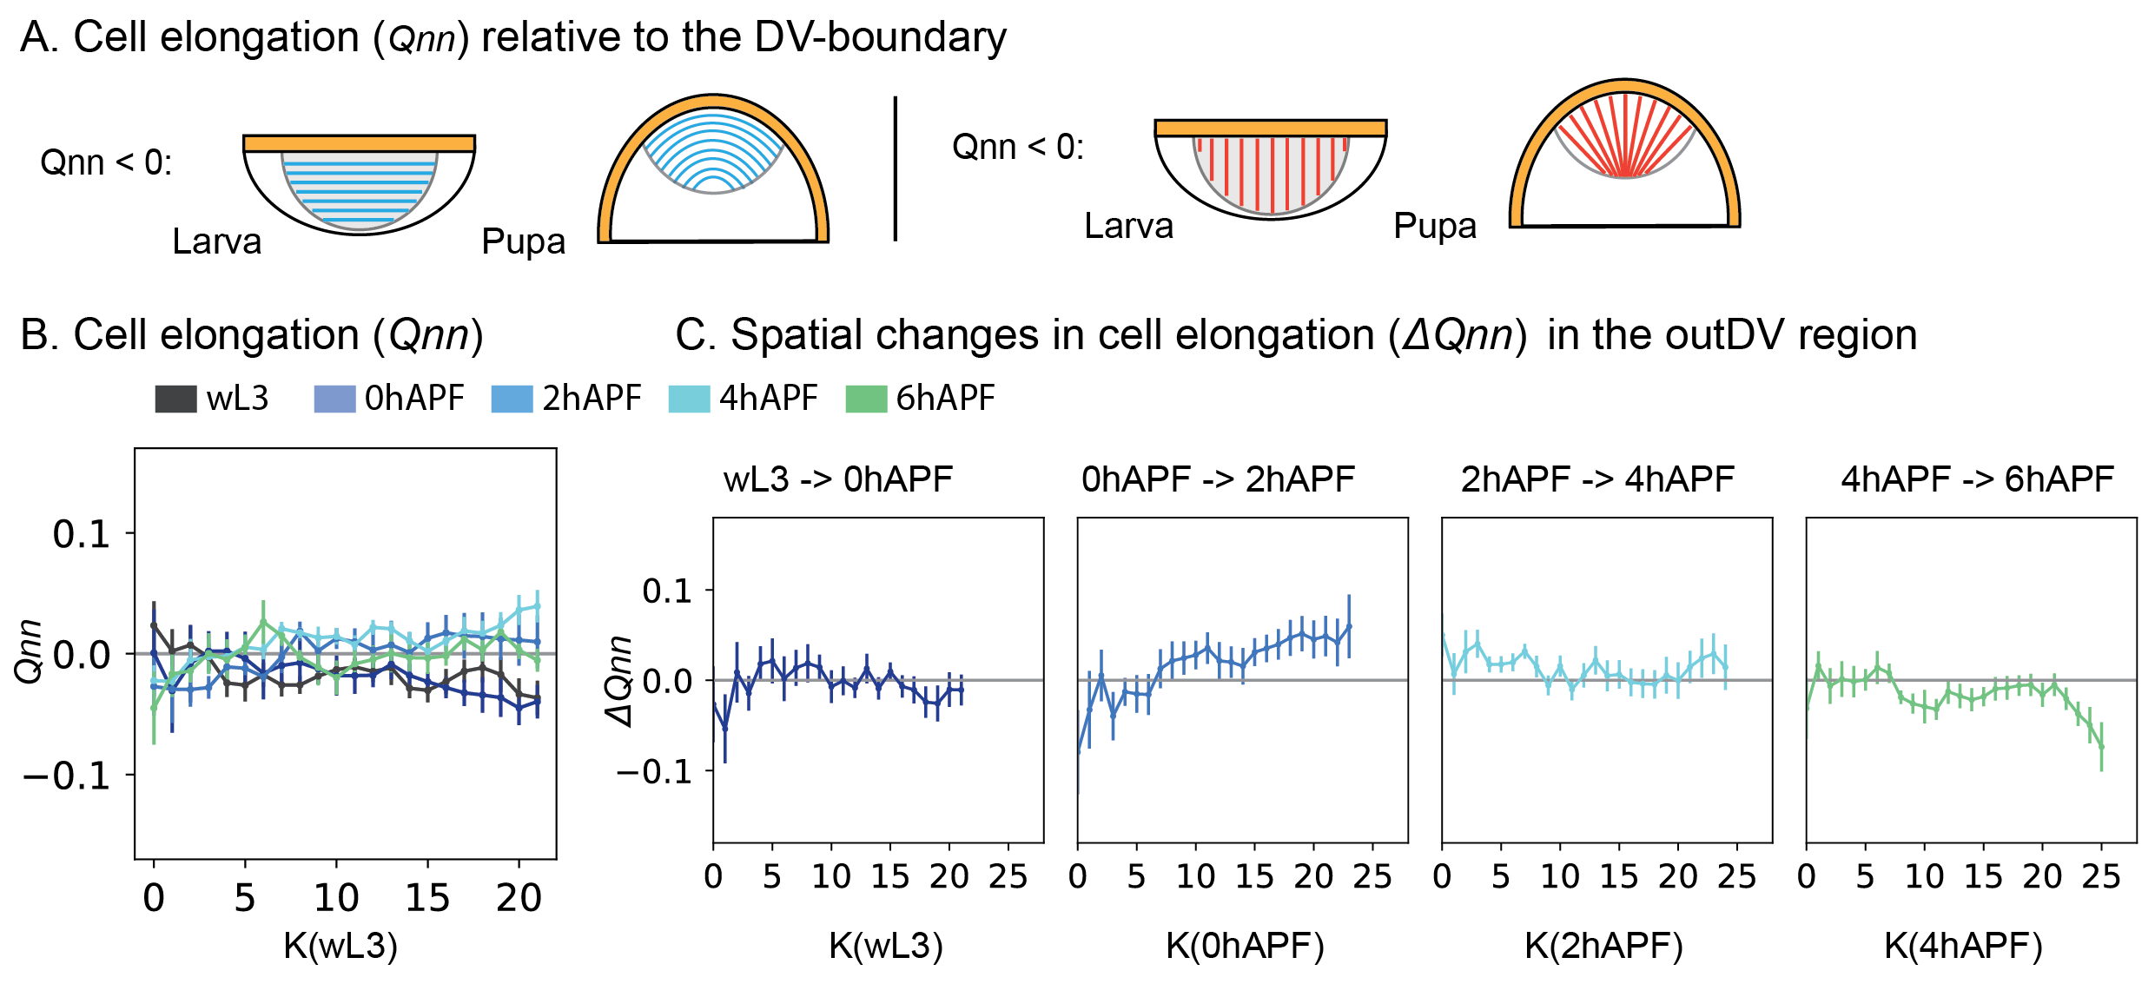

Figure ‑| Potential role for the DV-boundary as nematic organizing region

Cartoons showing nematic organization by *Qnn* in the outDV region. DV‑boundary in orange, outDV region for larval and pupal stages, blue lines indicate the elongation, orientation required for negative values of *Qnn*, red lines indicate the positive values of *Qnn* in the topologically defined region. Profile of *Qnn* over K, where k (wL3) is used as reference (B) Colors correspond to developmental stages as indicated. Spatial profile of consecutive cell elongation changes *(ΔQnn).* Timesteps for each plot are indicated above, colors correspond to the respective final timepoint, K is based on *k* (initial) (C).

Thus, whichever nematic displays larger absolute values can be considered dominant. Since the absolute values for *Qrr* are larger, than the changes along *Qnn*, we conclude that a circular pattern is the dominant pattern during growth and evagination.

### Change in tissue topology

The development of tools for the calculation of unidirectional, spatial effects by topological rearrangements was done in collaboration with Abhijeet Krishna

Cell elongation is not the only unidirectional cell behavior that can modulate tissue shape. Oriented cell rearrangements and divisions can also lead to unidirectional effects, thus I decided to further investigate the role of such topological changes in the tissue. Topological changes in the Tissue involve rearrangements, divisions and extrusion and can be quantified on the basis of cell neighbor relationships. T1 transitions can increase or decrease the number of neighbors per cell and thus lead to changes in the topological arrangement of the tissue. Depending on the orientation of the new bond, a T1 transition can be characterized as radial or tangential in orientation. Cell rearrangements by T1 transitions affect not only their immediate neighborhood, but can shift the topological distance for subsequent cells in a complex way that depends on cell shapes and tissue packing topology (Figure 1‑16 A.i). This makes it impossible to calculate the absolute number of T1 events, yet collective, unidirectional effects along k can still be quantified. A similar phenomenological description can be done for cell division and extrusion: Cell divisions always increase the Number of cells per k, (*n(k)*), yet the daughter cells can either stay in in the same *k* as the mother or contribute in *k* +1, depending on the orientation of division. A contribution to k-1 would involve an additional T1 rearrangement and is thus not the immediate effect of the division (Figure 1‑16 A.ii). Cell extrusions decrease *n(k)* locally (Figure 1‑16 A.iii).

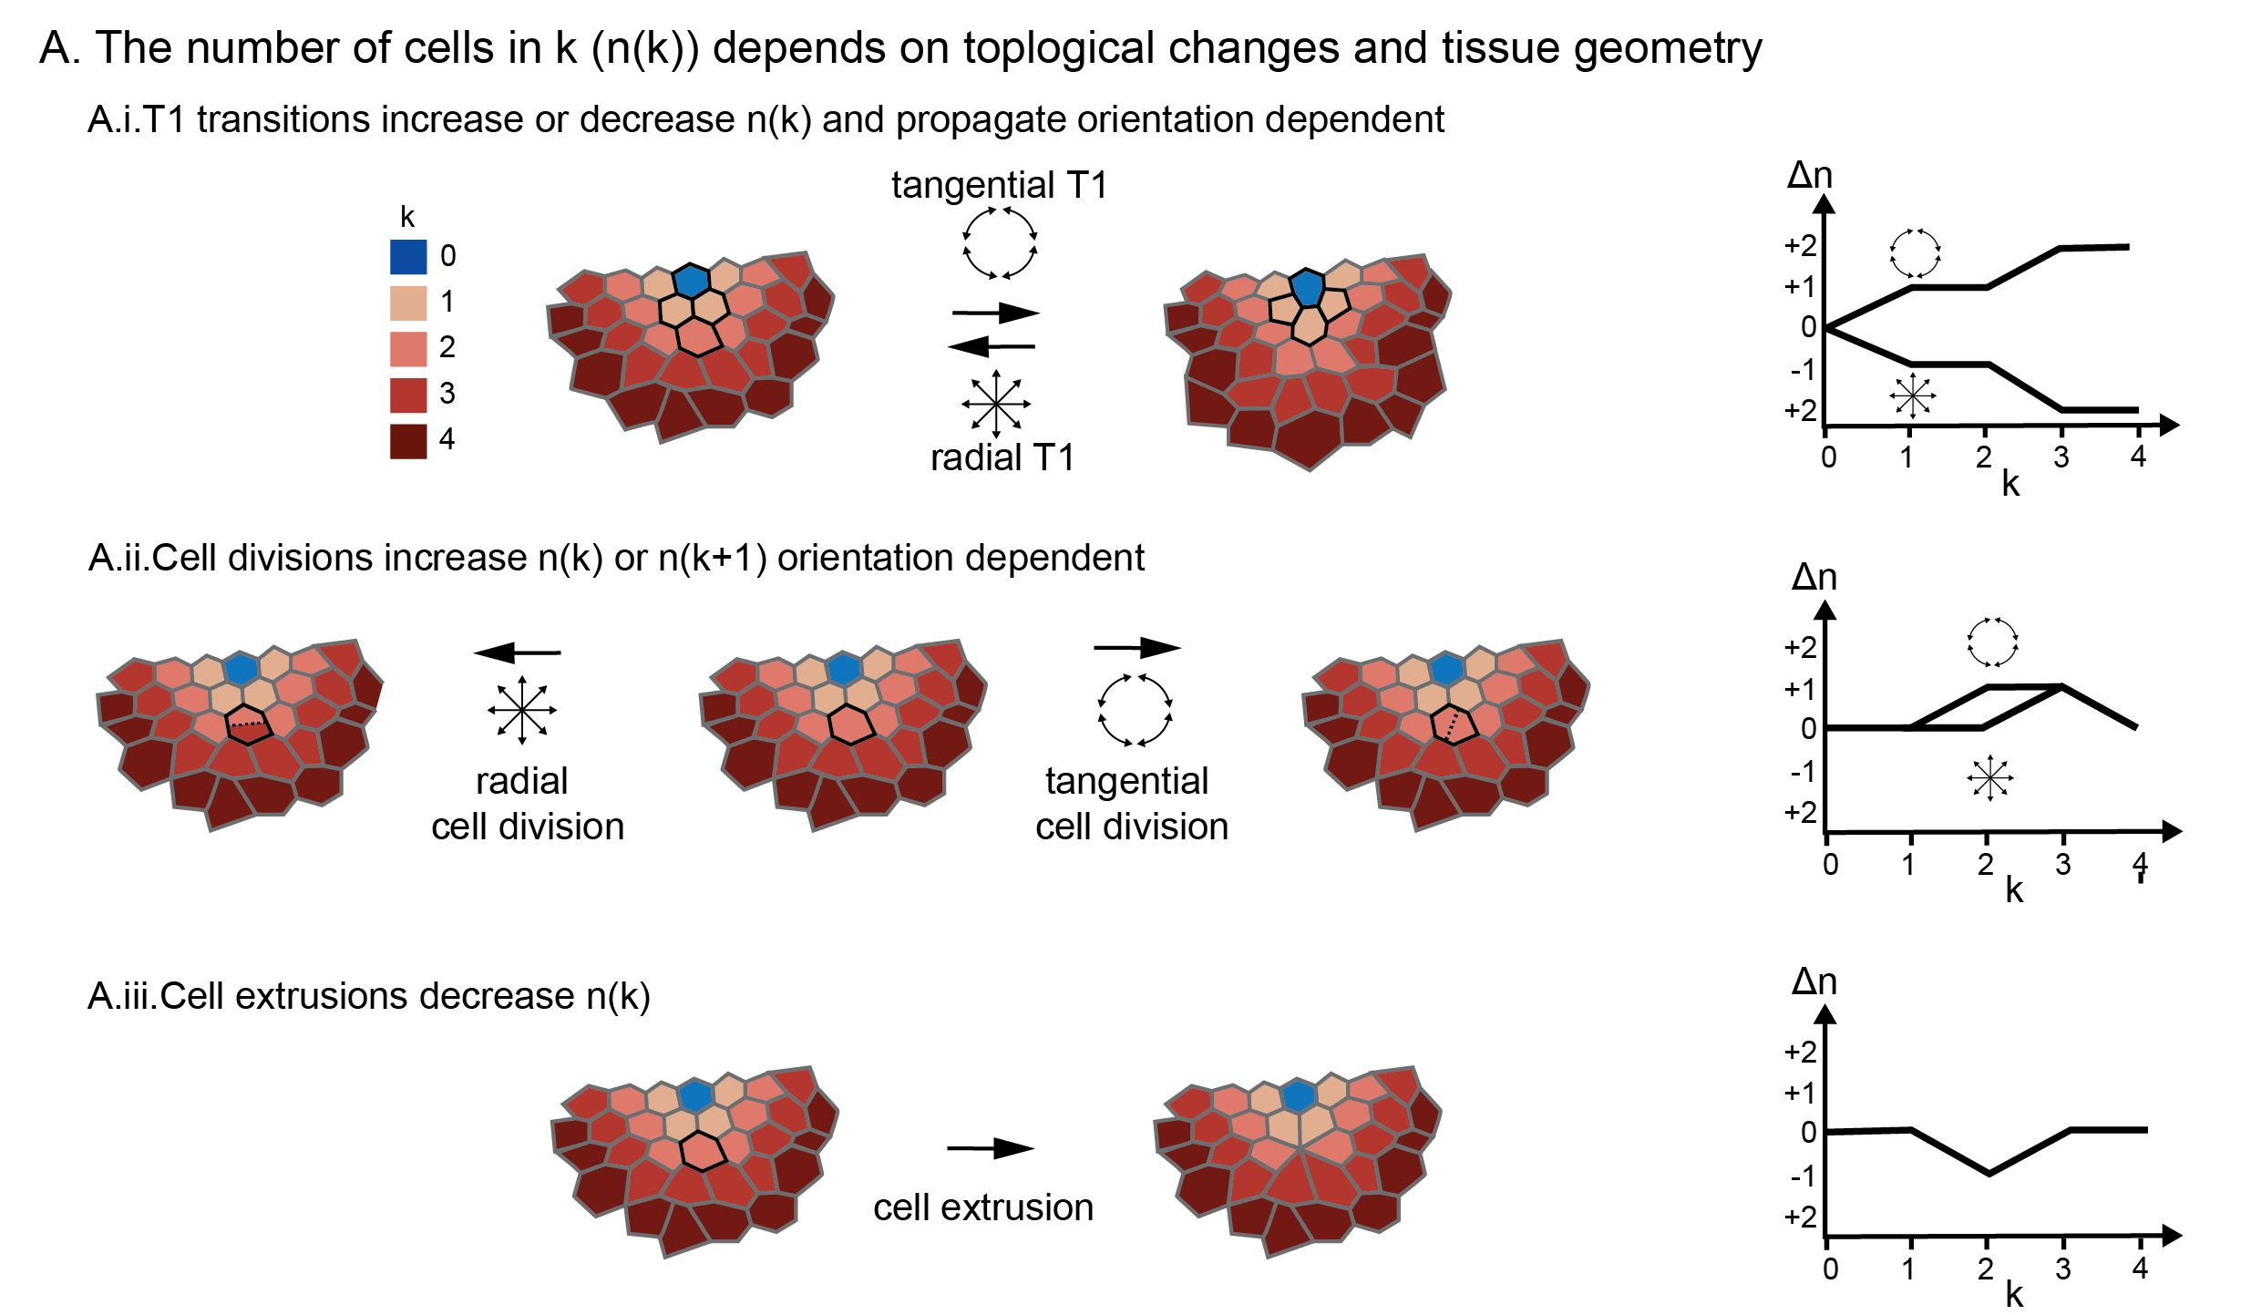

Figure ‑| The number of cells per k changes with topology

Different topological changes lead to a change in n(k). Graphs show the change in number of cells (Δn) over k after a topological change (A). T1 transitions can be tangential or radial, the direction is defined by the orientation of the new bond. T1 transitions affect the number of cells within their topological bin, as well in consecutive bins (A.i) cell divisions increase the number of cells in the topological bin of the mother cell (*k*), or the subsequent bin (*k*+1) (A.ii). Cell death decreases *n(k)* for *k* of the dying cell (A.iii).

Because growth is arrested during evagination, I preserve the cumulative number of cells (N) while comparing tissue patches over time. While cropping the discs, I allow for the maximum k to accommodate a fixed value of N. (see section 1.2.3). The relationship between *N* and *k* contains information about unidirectional topological changes (Figure 1‑17 A, C). I observe a non-linear relationship for k(N) in the outDV-region, and increasing n(k), numbers of cells per k ring. Over developmental time, *k* needs to increase to achieve the same *N*, for the outDV region. This effect is also observable in the decrease in n(k) (Figure 1‑17 B). These observations have a number of implications: The topological bins by *k* contain more cells as the distance to the center increases. This contributes to the circular shape of the tissue, if n(k) were constant, one would expect a rectangular shape (under the assumption that that cell shapes are uniform along k). This is the pattern observed for the DV‑boundary. Moreover, I need to include a larger topological distance to the center to contain the same number of cells, as development proceeds, this shows that there is indeed a unidirectional effect by topological changes. If this weren’t the case, any topological changes would average each other out and these tissue wide effects could not be seen. As I need larger k, it can also be concluded that topological changes happen along k and not tangential to it. Thus, the cumulative topological changes are oriented along the radial direction.

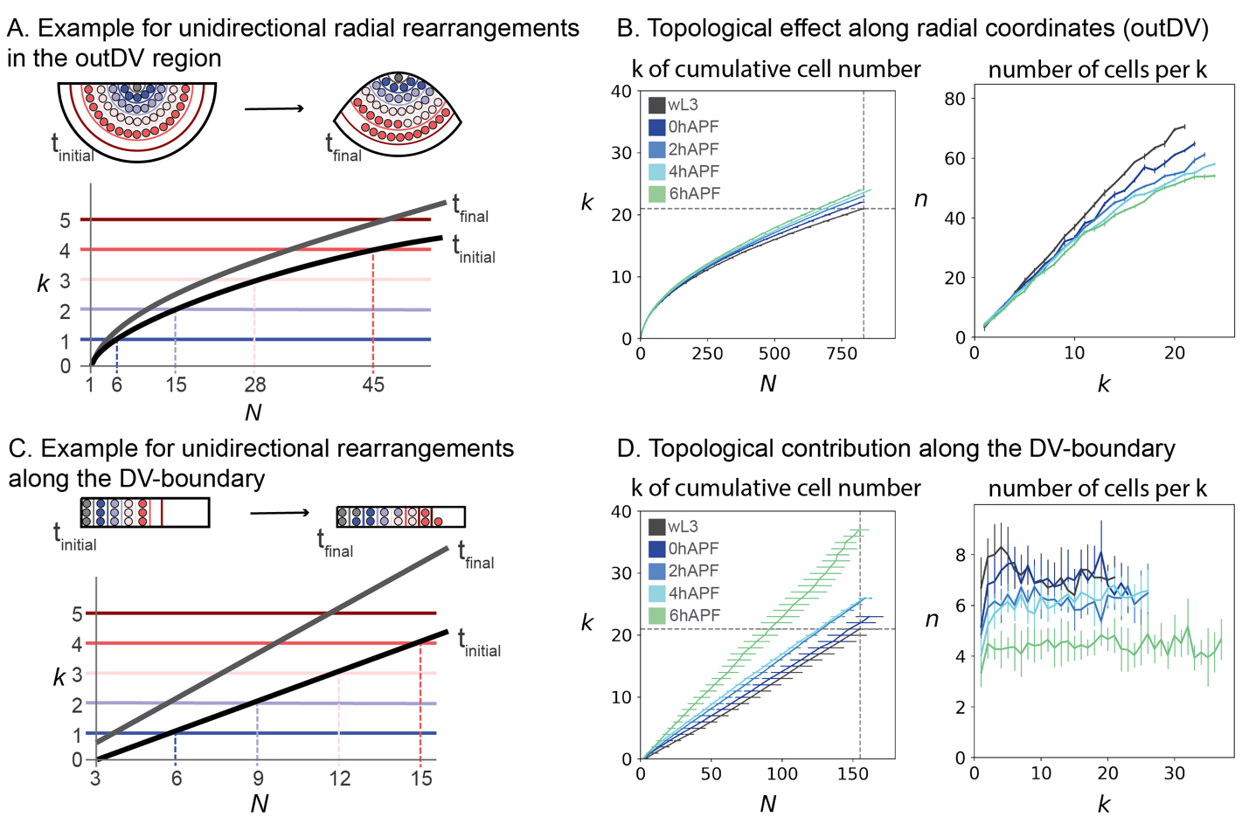

Figure ‑| Coarse grained topological effects

The cumulative effects of topological behaviors can be observed by the relationship between N and k (A, C). the topological distance *k* is plotted against the cumulative number of cells N and the number of cells per bin (n) is plotted against *k*. Colors indicate developmental timepoints, error bars show the 95% confidence interval of the mean for the average of all discs per timepoint (B, D). all cells in the topologically defined region of the outDV (B) and DV-boundary (D) regions are quantified. Error bars indicate the 95% confidence interval of the mean over all disc per timepoint (B, D)

This is similar for the DV-boundary, we observe a dramatic increase in *k* at maximum *N* (*k(max)*): *k(max)* = 21 to *k(max)* = 27 after eversion (4 hAPF) and *k(max)* = 38 at 6 hAPF. For each developmental stage, *k(N)* and *n(k)* are linear and *n(k)* has no slope. This means that the topological width of the DV-boundary does not change by distance to the center and topological changes are uniform. n*(k)* decreases over time as compared to the wL3 stage by a factor of 0.8 during eversion, and 0.6 at expansion, similar to the outDV scenario this reveals a unidirectional effect by topological changes along the DV‑boundary in *xx* direction (Figure 1‑17D)

Anisotropic contributions to tissue shape cannot directly be compare on *k*, as *k* changes over time to accommodate the same number of cells. *k(N)* shows cumulative effects of topological behaviors, but no spatial information. To understand spatial changes in topology, we further investigate the relationship between *k* and *N*. For the initial timepoint (*t*), the cumulative number of cells *N* is covered by *k* distance: $k(N)$. The number of cells in a given ring with, depends on tissue topology and is given by, where is the cumulative number of cells till the th k ring. To understand cumulative effects of rearrangements in the DV and outDV region, we can calculate for the difference in between timepoints ( $t$ and t+ $∆t$) for an for timepoint:

$$∆_{t}k\left(N_{i}\right)=k\left(N_{i},t+∆t\right)-k(N_{i},t)$$

From here we get the spatially local effect of uniaxial contributions for topological rearrangements by taking a difference of between consecutive values :

$$∆_{t}∆_{N}k\left(N_{i}\right)=∆_{t}k\left(N_{i+1}\right)-∆_{t}k(N_{i})$$

We next calculate this value along the direction of *k* for the DV and outDV region (Figure 1‑18 A).

We find, that throughout eversion and expansion, $∆_{t}∆_{N}k\left(N_{i}\right)$ is positive along *k* for the outDV region. This effect leads to an effective tissue expansion along the radial direction, and a shortening along the tangential direction (Figure 1‑18 B). In the DV‑boundary we observe slightly anisotropic changes in $∆_{t}∆_{N}k\left(N_{i}\right)$ at wL3 to 0 hAPF and 0-2 hAPF: distally, topological changes elongate the DV‑boundary and in the periphery, they lead to a widening. These effects are subtle, however, as compared to the increase in length at 0-2 hAPF and 4-6 hAPF (Figure 1‑18 C).

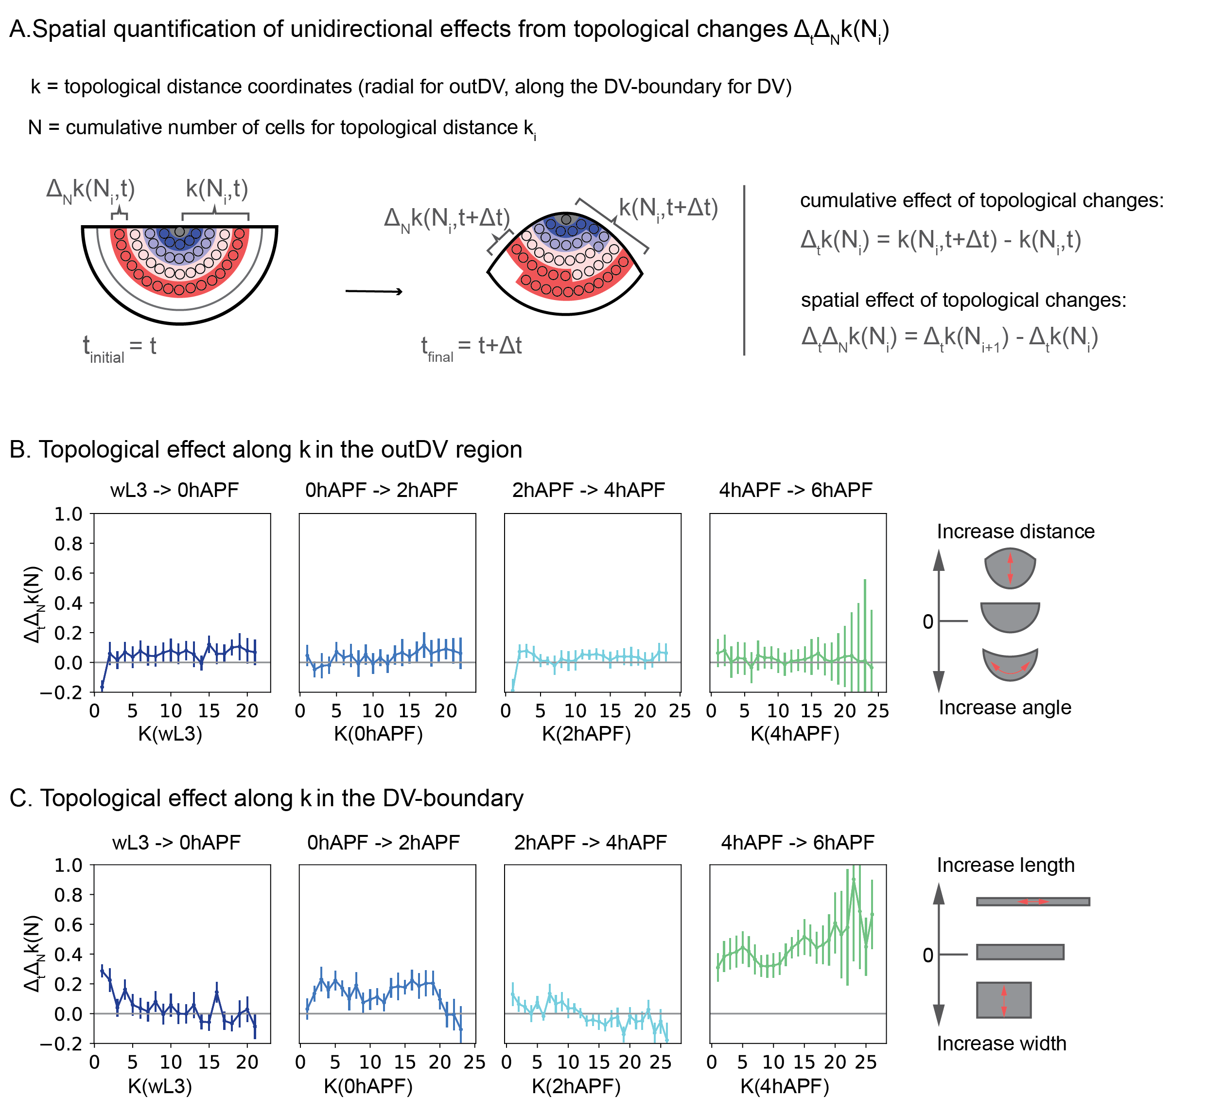

Figure ‑| Quantifying unidirectional effects by topological changes

Schematics describing the methodology for spatial topological analysis (A). Spatial contributions by topological changes for consecutive timepoints along k for outDV and DV-boundary (B, C) Timesteps for each plot are indicated above, colors correspond to the respective final timepoint, K is based on *k* (initial) (B, C). Error bars indicate the 95% confidence interval of the mean over all disc per timepoint (B, C)

Topological changes per k, change the width of the outDV region and the DV‑boundary, yet they are not a measure for the actual topological width, that is, the shortest distance along the width of the DV‑boundary. To estimate this effect for the DV‑boundary, I compared *n(k)* with the topological width of the DV‑boundary. I observe, that those two metrics generally agree well with each other. The topological width of the DV‑boundary decreases most dramatically at 0-2 hAPF and at 4-6 hAPF as is in accordance with our observations on $∆_{t}∆_{N}k\left(N_{i}\right)$. I do observe a mismatch in the average number of cells per k and the average number of cells along the DV-width of about 1 cell. This mismatch vanishes at 6 hAPF, indicating that in the case of a few cells along width of the DV‑boundary, k (n) leads to an almost perfect approximation of the topological width.

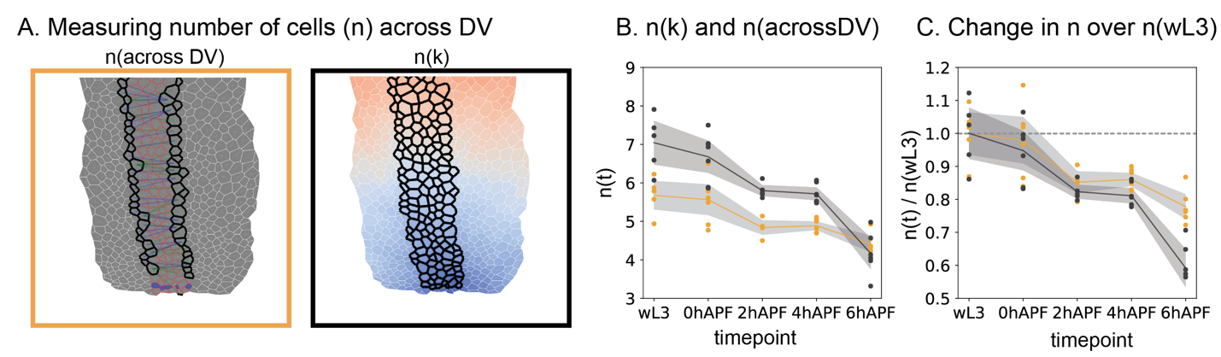

Figure ‑| n(k) resembles the topological width qualitatively, but not quantitatively

DV-boundary view showing the difference between the shortest topological width (*n(across DV)*) and *n(k)* for a 4 hAPF wing disc. n(across DV) is defined by the topological distance between DV-boundary cells at the margin of the DV‑boundary (outlined in black). The DV-boundary cells are outlined in red. For each margin cell the shortest path to the other side is found, blue and green lines indicate such paths. Comparison of average n for both methods (B) and change in n over n(wL3) (C). Each datapoint corresponds to the average for one disc, the grey region shows the 95% confidence interval of the mean (B,C). black = n(k), orange = (n(across DV)

In summary, our methodology can identify cumulative, uniaxial topological effects in static data. Although we are unable to dissect individual contributions by cell division, extrusion and number of rearrangements, we find that topological changes increase the tissue along its proximal-distal direction. This uniaxial effect is likely to contribute to wing disc evagination.

### Summary wildtype

Our spatial analysis allows us to compare tissue shape changes to spatio-temporal changes in cell packing geometry and topological changes.

From wL3 to 0hAPF: the tissue undergoes only small changes in its curvature along the DV-boundary, but anisotropically increases curvature along the PD-axis. The curvature increases in the center, but not the periphery. During this process, we observe an anisotropic cell area increase in both tissue regions. The uniaxial effect of cell elongations is tangential in the outDV region and along the axis of the DV-boundary, topological effects are both positive, contributing to an increase in length along the radial direction for the outDV region and along the boundary for the DV-boundary

From 0- 2 hAPF: the curvature increases homogeneously along the PD-axis and not along the DV‑axis. For cell shapes we observe similar behaviors as between wl3 and 0 hAPF, except that there is no cell area increase in the DV-boundary and the boundary elongation effect by rearrangement becomes stronger at the same time.

From 2‑ 4 hAPF: tissue curvature increases homogeneously along the PD‑axis, and the DV-axis. The area increase is reversed between tissue regions; areas in the DV-boundary increase, whereas they do not change in the outDV region. This area increase is accompanied by a relaxation of cell elongations in the DV-boundary. In the outDV region, elongations and rearrangements are both positive, contributing to radial tissue expansion.

From 4‑ 6 hAPF: tissue curvature increases further along the PD-axis. I observe homogenous area expansion throughout the tissue and tissue flattening. Cells become isotropic, which contributes to tissue expansion along k and we observe strong uniaxial, positive topological effects along the DV-boundary and continued topological effects along k in the outDV region.

Taken together, I have quantified tissue curvature changes and corresponding cellular size, shape and topology changes throughout all timesteps of evagination. Interestingly, changes in the DV‑boundary and outside the DV‑boundary can be temporarily decoupled, as seen by area changes from 0- 2 and 2- 4 hAPF. Another such decoupling is seen in the changes of cell elongation from wL3 -0 hAPF and 2‑ 4hAPF. Topological changes appear to be relatively constant in orientation and magnitude over development. They are generally homogenous and positive for the outDV region and positive, yet a bit more variable in the DV‑boundary. The only exception is the dramatic increase in rearrangements in the DV‑boundary during wing expansion.

Interestingly spatial gradients of cell behaviors are predominantly seen in cell area changes and rearrangements and less in cell elongations. This puts emphasis on an important distinction between cell area changes, and rearrangements and elongation: cell area changes are isotropic deformations and only generate anisotropic tissue shape changes if combined with an inhomogeneous spatial distribution. Rearrangements and cell elongations are always uniaxial and can generate anisotropic tissue shape changes independently of their spatial distribution.

## Perturbation of cell and tissue shape using MyosinVI RNAi

Our analysis revealed that changes in tissue morphology are accompanied by spatio-temporal changes in cellular packing geometry. To test the effects on changes in cell shape and topological rearrangements, we used a tissue specific knockdown using a UAS-Gal4 approach. We use nubbin-Gal4 (nub-Gal4) to express Gal4 in the wing pouch across all evagination stages. We also observe that Gal4 is expressed over the first fold, surrounding the pouch region (HP-fold) and up to the beginning of the HH-fold on the dorsal side. On the ventral side the expression domain covers one additional small fold (Figure 1‑20 A).

We decided to knockdown *Drosophila* MyosinVI using a UAS RNAi construct (UAS-MyoVIRNAi) construct in the background of Ecad::GFP. MyosinVI is a minus end-directed actin motor protein and has been shown to act as a force sensor by interaction with E-cadherin at adherens junctions. MyosinVI conveys information of junctional tension though its activation of RhoA signaling in response to mechanical stress (Acharya et al., 2018). Apart from that role, it is involved in different cellular processes such as vesicle transport, autophagy, and clathrin-mediated endocytosis (Magistrati & Polo, 2021). It is its potential role as a mechanosensor, that motivated MyosinVI knockdown experiments in the wing disc at 120 hAPF (Dye et al., 2021). In this work, knockdown of MyosinVI leads to a decrease in tangential cell elongation and a flattening of the elongation gradient. At the same time MyosinVI RNAi leads to an increase in cell areas in the wing pouch, while the cell area gradient is not affected. Dye, Popović et al., conclude that the cellular packing geometry and oriented rearrangements in the wing disc arise through a self-organized mechanochemical feedback loop, which can be perturbed by knocking down a mechanosensitive component: MyosinVI. These results motivated us to study the effects of MyosinVI during wing evagination. With MyosinVI RNAi experiments we expect to perturb mechanosensitive cell shape changes as well as topological changes.

### MyosinVI knockdown affects tissue shape changes during evagination

We investigated tissue shape changes in the PD‑cross‑section during evagination in nub‑Gal4, MyosinIV knockdown wing discs. It is important to note that only the fold immediately to the pouch (HP‑fold) is affected by the knockdown and no major conclusions can be drawn on effects on fold morphology. It can be noticed, however, that the HP-fold does not appear visually different than the HH and HN‑folds. Indicating that MyoVI likely has no effect in fold formation or opening during eversion (Figure 1‑20 B).

Next, we quantified the shape of the pouch and found, that we do not see any difference along the DV-boundary in MyoVIRNAi as compare to wildtype. Along the PD-axis, the pouch shape at wL3 stage is still similar between MyoVIRNAi and wildtype. Yet, a difference in shape becomes increasingly pronounced as eversion proceeds: In wildtype, the dorsal and ventral half approach each other throughout eversion and expansion, in MyoVIRNAi, the dorsal and ventral half remain remote up to 4 hAPF and approach less than wildtype at 6 hAPF. We also observe that the tissue remains flat, or if anything a bit dented inwards at the DV-boundary during eversion (Figure 1‑20 B, C). We further investigated tissue shape and curvature in the topologically defined region. We find that at wL3 stage the curvature in both directions resembles the curvature in the wildtype. Unlike the wildtype however, the curvature in the center along the PD-axis decreases and finally reaches zero at the end of eversion, while further away it remains positive. At the expansion (6 hAPF) tissue curvature eventually becomes positive again in the center (> 0.01 µm2). Yet, it is almost 6‑fold lower than in the wt. At the DV-axis, as observed by the similarities for tissue shape, we do not observe major differences to the wt. However, we saw a minor increase in curvature from wL3 to 4 hAPF in wildtype (~0.005 µm-1), which we don’t see in MyoVIRNAi (Figure 1‑20 D, E).

In summary, we observe that MyosinVI knockdown wing discs fail in the apposition of the wing bilayer, and flattening of the dorsal and ventral tissue halves. These changes result in a failure to generate a peak curvature at the future wing margin.

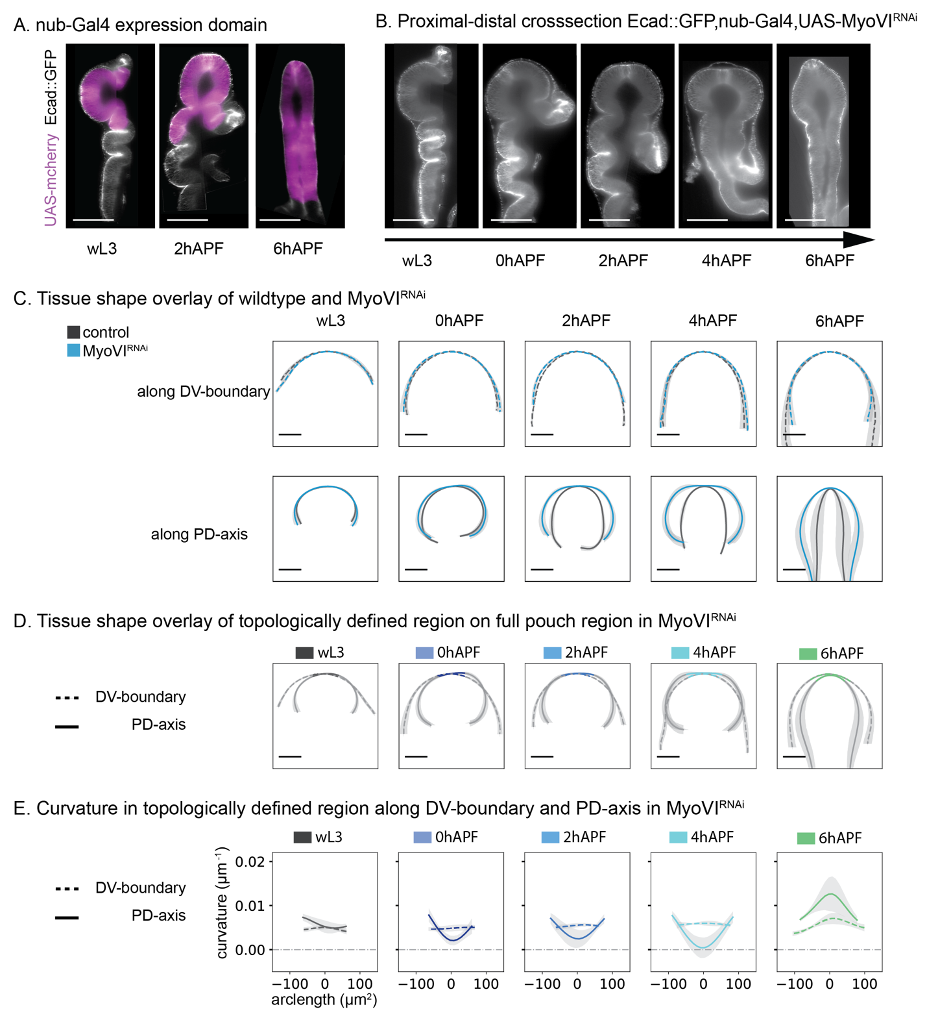

Figure ‑| Tissue shape changes during evagination of MyosinVI knockdown wing discs

PD-axis crosssection view of wing discs during evagination. Apical cell junctions are labelled with Ecad::GFP (A, B). nub-Gal4 expression domain (magenta) on wL3, 2 hAPF and 6 hAPF (A) nub-Gal4, UAS-MyoVIRNAi knockdown discs for developmental stages wL3, 0, 2, 4, 6 hAPF (B). Tissue mean shape overlay between control (Ecad::GFP,nub-Gal4, in black) and MyoVIRNAi (blue) wing disc pouch. Along DV-boundary crosssection (dashed line) and along PD-axis (solid line) 95% confidence interval of mean for x and y positions is indicated in grey (C). Tissue shape overlay of full pouch shape and topologically defined region (colors = developmental stage) for MyoVIRNAi. DV-boundary = dashed line, along PD-axis = solid line (D). Curvature in µm-1 for MyoVIRNAi in topologically defined region. colors = developmental stage, DV-boundary = dashed line, along PD-axis = solid line. Scale bars = 100µm

### MyosinVI knockdown affects area increase and cell volume

To test if the shape phenotype can be explained by changes in cell shapes, we next quantified the spatial patterns of cell area and elongation. As expected from the data by Dye et al., 2021, we observe a cell area gradient similar to the gradient in wildtype but with slightly larger cell areas (average cell area: wildtype = 5µm2, MyoVIRNAi = 7µm2 in outDV region at wL3, 95% confidence for slope: wildtype = 0.080 +/- 0.019, MyoVIRNAi = 0.085 +/- 0.023). During tissue morphogenesis, these gradients change: In the outDV region, cell areas expand and the area gradient is resolved by 4 hAPF, whereas cell areas are slightly reduced at 6 hAPF (Figure 1‑21 A). In the DV-boundary we do not observe any change in cell areas during eversion, but a more then 2‑fold cell area expansion from 4 hAPF to 6 hAPF (Figure 1‑21 C).

As compared to the area changes in wildtype, the area increase in the outDV region is qualitatively similar at 4 hAPF, but the spatial dynamics differ: cell areas only start increasing after 0 hAPF. In the DV-boundary, cell areas do not increase during eversion but do so at expansion, this is different from the wildtype, which also expands during tissue expansion but as already obtained a 2‑fold area increase by the end of eversion on top of that. The most dramatic change of behavior in MyoVIRNAi is observed from 4-6 hAPF in the outDV region, during which cell areas slightly decrease which is contrary to the expansion observed in wildtype (Figure 1‑21 B, D).

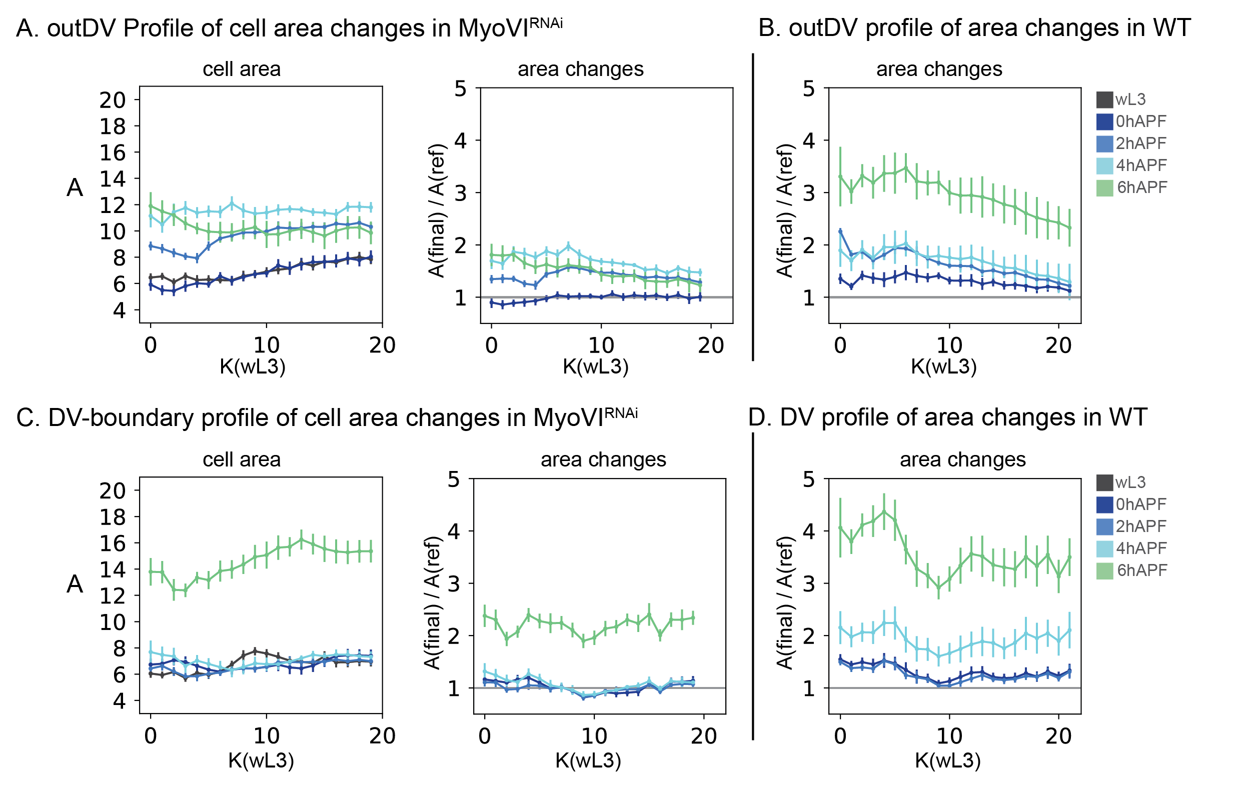

Figure ‑| Spatial changes in cell area for MyoVIRNAi

Profiles for cell area for MyoVIRNAi (A, C). Profile of cell area over K, where *k*(wL3) is used as reference, for outDV (A) and DV‑boundary region (C). Colors correspond to developmental stages as indicated on the right. Spatial profile of consecutive cell area changes (A(final)/A(ref)). The reference timepoint is wL3 for all stages, colors correspond to the respective final timepoint, K is based on *k*(wL3) (A, C) Spatial profile of consecutive cell area changes (A(final)/A(wL3)) in wildtype for outDV (B) and DV-boundary (D) region. Error bars indicate the 95% confidence interval of the mean over all discs for each timepoint.

To test, if the changes in cell area gradient are due to differential cell volume changes, we quantified tissue height and approximated tissue volume (Figure 1‑22 A, C). We observe similar differential changes in cell height as in wildtype, although the pouch fails to flatten as dramatically. Cell volumes are similar to the wildtype for initial stages, yet the slope in volume across the PD-axis is stronger in MyoVIRNAi. We quantify average volume for all timepoints and observe that MyoVIRNAi has a larger cell volume at wL3 as compared to wildtype, which is in accordance with the bigger cell areas at similar tissue height (Figure 1‑22 B, D). Next, we tested if there are significant changes in volume over all developmental stages as compared to wL3. In the in the outDV region in wildtype discs, cell volume increases by ~30µm3 (corresponding to an increase by a factor of 1.1-1.2) during eversion and decreases thereafter. In MyoVIRNAi this increase is more dramatic corresponding to a ~1.7-fold increase in cell volume at 4 hAPF (Figure 1‑22 B). Interestingly MyoVIRNAi discs temporarily decrease cell volume at the same time in the DV‑boundary, while they remain constant in wildtype (Figure 1‑22 D).

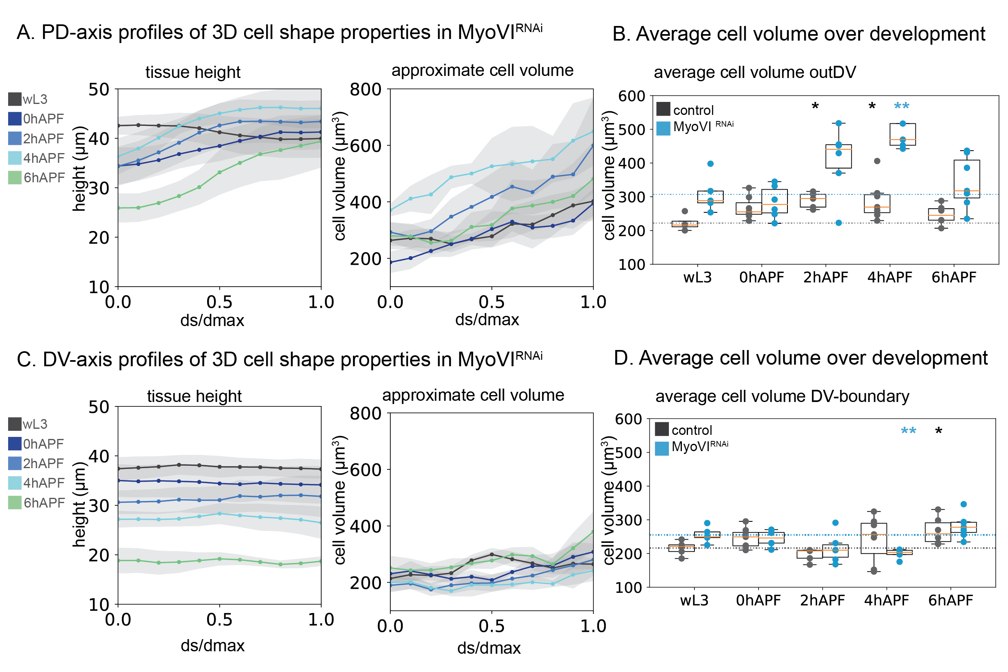

Figure ‑| Cell volume changes during MyoVIRNAi evagination

Spatial profiles by a fraction of distance over the maximum distance covered (ds/dmax). ds/dmax is averaged in 0.1 steps, developmental stages are indicated by color, grey region shows 95% confidence of the mean for all wing discs analyzed. Tissue height and approximate cell volume are calculated along the PD-axis (A) and the DV‑boundary (C). Average cell volume, for wildtype in black and MyoVIRNAi in blue. Each datapoint is one wing disc, boxplots show the median in orange, box shows upper and lower quartile values, whiskers extend 1.5 beyond upper and lower quartile. Dotted line shows the mean for wL3, for each genotype (B, D). Average volume for the PD-axis (B) and the DV‑boundary (D). Asterisks show statistical significance for each timepoint as compared to wL3 of the same genotype (Mann‑Whitney U, two-sided, method=exact, **: **: 1.00e-03 < p <= 1.00e-02, *: 1.00e-02 < p <= 5.00e-02. No asterisk: 5.00e-02 < p)

### MyosinVI knockdown affects cell elongation quantitatively but not qualitatively

Dye, Popović et al., reported an effect of MyoVIRNAi on cell elongation, this effect might be due to mechanosensitive feedback leading to oriented rearrangements, which in turn can increase cell elongation. But it could also be due to a direct polarizing mechanism leading to cell shape anisotropy. To address effects on, and contributions by, cell elongation, we investigated elongation profiles in MyoVIRNAi discs over development. We first compared the elongation profile and average for the outDV region at wL3 stage in wildtype and MyoVIRNAi and don’t observe significant differences (Figure 1‑23 A, C). This result is different from previously published results at 120 hAEL (Dye et al., 2021), indicating that at wL3 stage the initial differences in elongation during wing disc growth have resolved.

Over eversion, cell elongation changes are qualitatively similar between wildtype and MyoVIRNAi but quantitative differences are apparent on the average cell elongation: at 0 and 2 hAPF, in the outDV region, cells are more tangentially elongated in wildtype than in the knockdown, and at 4 hAPF cells are elongated more along the DV-boundary in the MyosinVI knockdown as compared to wildtype (Figure 1‑23 A, B). The spatial gradients at eversion are similar between wildtype and MyoVIRNAi. Cells in the periphery of the outDV region are elongated more tangentially and elongation in the DV-boundary is homogenous (Figure 1‑23 C- F). These similar gradients also lead to comparable spatial changes with the exception of the 4 hAPF DV-boundary region, with $Qxx=0$ in wildtype and $Qxx≈0.08$ in MyoVIRNAi (Figure 1‑23 E,F).

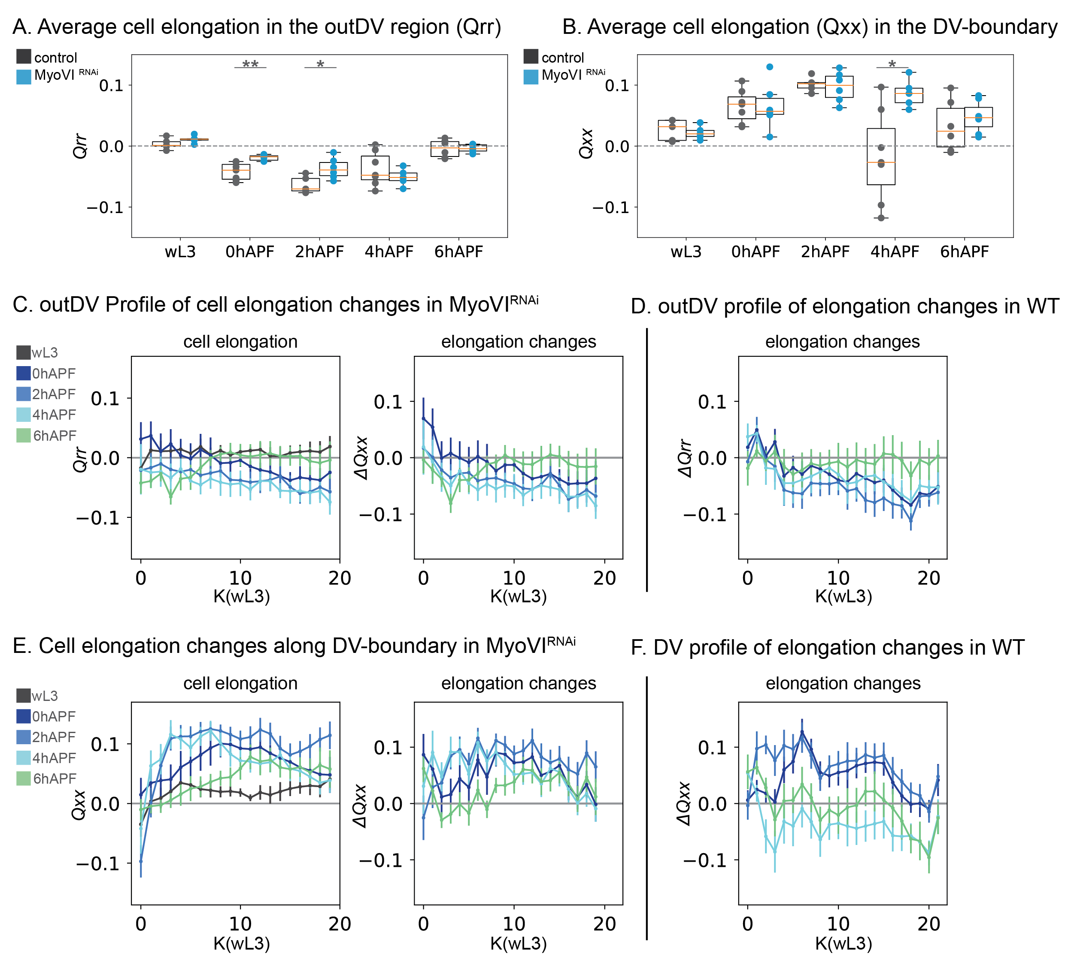

Figure ‑| Cell elongation in MyoVIRNAi

Average cell elongation: Qrr for outDV (A) and Qxx for the DV-boundary (B). Each datapoint is one wing disc, boxplots show the median in orange, box shows upper and lower quartile values, whiskers extend 1.5 beyond upper and lower quartile. Dashed line shows no cell elongation profile for comparison (Q = 0). Average elongation for the outDV region (A) and the DV‑boundary (B). Asterisks show statistical significance for each timepoint as compared to wL3 of the same genotype (Mann‑Whitney U, two-sided, method=exact, **: **: 1.00e-03 < p <= 1.00e-02, *: 1.00e-02 < p <= 5.00e-02. No asterisk: 5.00e-02 < p) (A, B). Profiles for Qrr (C) and Qxx (E) for MyoVIRNAi over K, where *k*(wL3) is used as reference, for outDV (C) and DV‑boundary region (E). Colors correspond to developmental stages as indicated. Spatial profile of consecutive cell elongation changes *ΔQrr* (C) and *ΔQxx* (E). The reference timepoint is wL3 for all stages, colors correspond to the respective final timepoint, K is based on *k*(wL3). Spatial profile of consecutive cell elongation changes *ΔQrr* (D) and *ΔQxx* (F) of wildtype discs for comparison. Error bars indicate the 95% confidence interval of the mean over all discs for each timepoint.

### Reduced unidirectional topological changes in MyoVIRNAi

Given the potential interaction between mechanosensitive signaling via MyosinVI and oriented rearrangements, we next address the topological effects in the tissue. We observe that the maximum topological distance in the outDV region, increases from k (max) = 19 for wL3 and 0 hAPF to k (max) = 20 for 0-6 hAPF (Figure 1‑24 A, C).

For the outDV region, spatial analysis reveals an increase in $∆_{t}∆_{N}k\left(N_{i}\right)$. This increase is homogenous throughout the tissue, but less than what we observed for the wildtype. As expected by the increase in k (max), we observe $∆_{t}∆_{N}k\left(N_{i}\right)>0$ for all timepoints in the outDV region, starting at 2 hAPF. However, we don’t observe as much of an increase in $∆_{t}∆_{N}k\left(N_{i}\right)$ over evagination as compared to the wildtype where it continuously increases up to $∆_{t}∆_{N}k\left(N_{i}\right)>0.1$ at 6 hAPF (Figure 1‑24 A, B, F).

In the DV‑boundary we see a increase in the number of cells per k, which temporarily decreases *k(max)*. This is reflected in the spatial profiles for $∆_{t}∆_{N}k\left(N_{i}\right)$, where we first see negative values, which indicates an increase in topological width, followed by a decrease in width at 4 and 6 hAPF. At 4 and 6 hAPF $∆_{t}∆_{N}k\left(N_{i}\right)≈0$ indicating that there is no net effect of topological changes at the end of eversion and expansion. We do not observe a spatial gradient in $∆_{t}∆_{N}k\left(N_{i}\right)$, although topological changes appear more spatially heterogenous, which can be an artifact of the small n(k) (Figure 1‑24 C, D, G). The observed behavior in the DV-boundary is different from the wildtype, where topological changes lead to an increase in DV‑boundary length most dramatically at 2 hAPF ($∆_{t}∆_{N}k\left(N_{i}\right)≈0.2$) and at 6 hAPF where $∆_{t}∆_{N}k\left(N_{i}\right)≈0.8$ (Figure 1‑24 D, G).

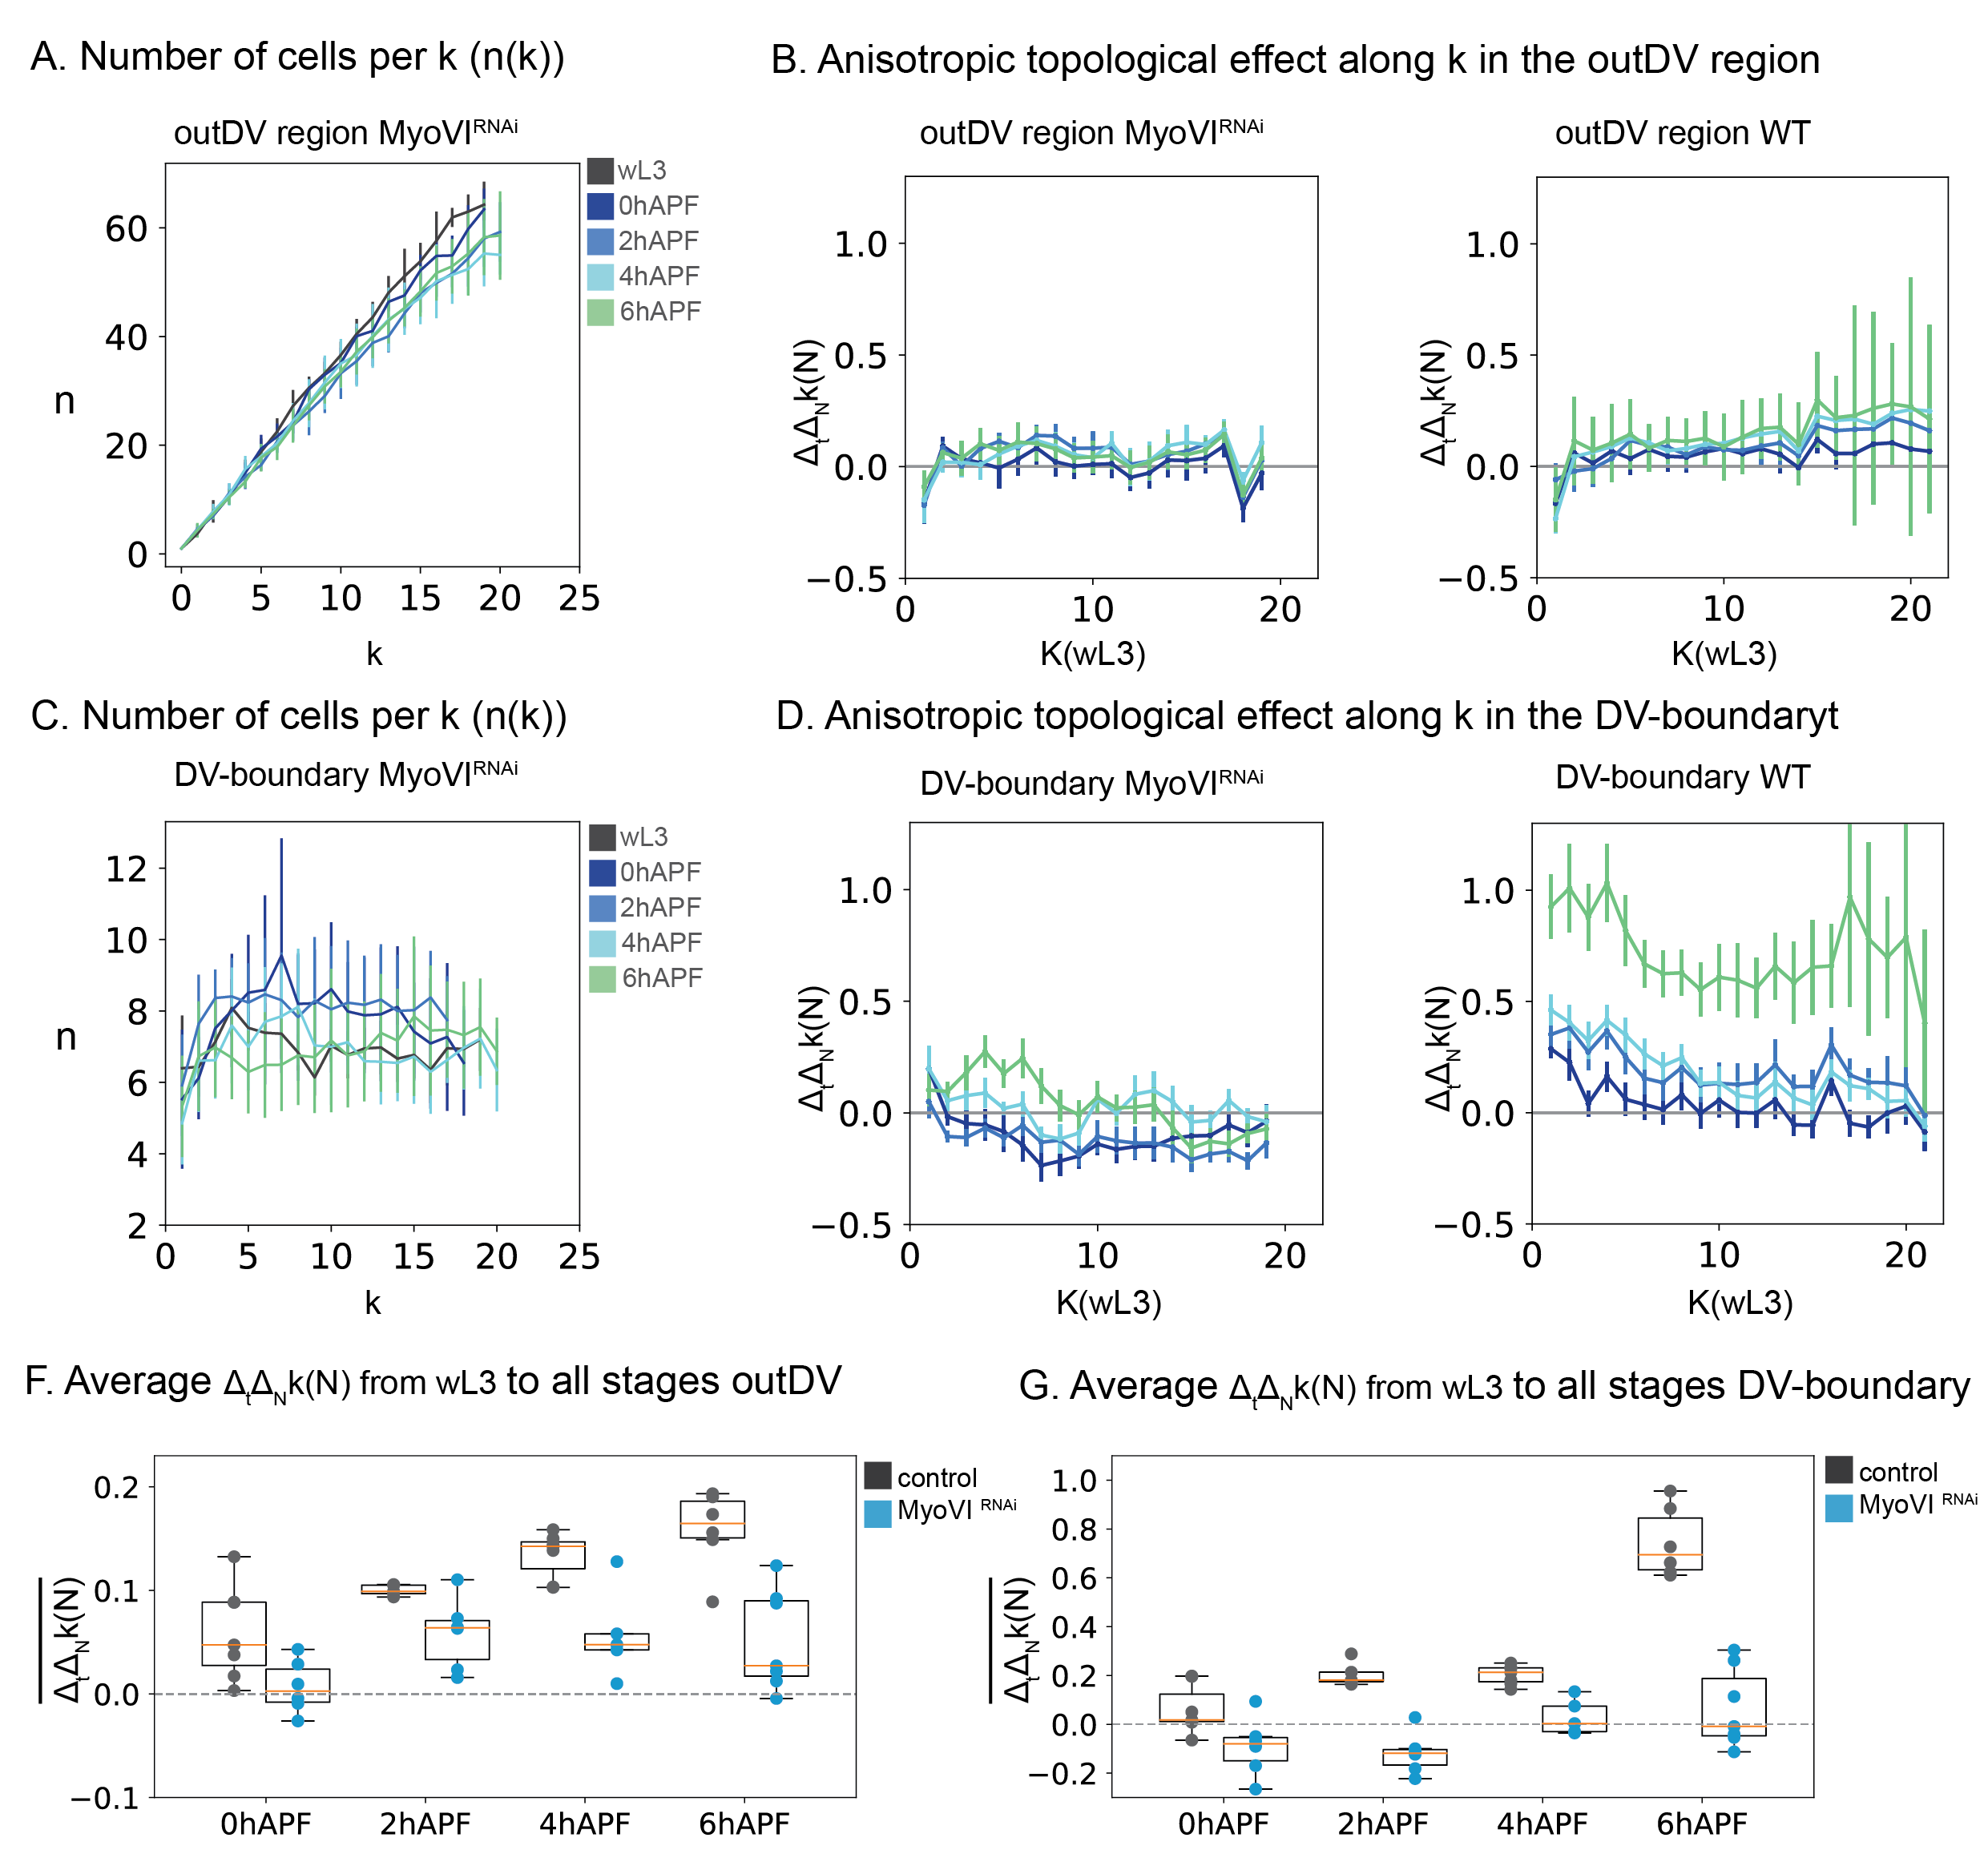

Figure ‑| Topological effects in MyoVIRNAi

Number of cells per *k* (*n(k)*) in the outDV (A) and DV-boundary (C). Profiles for $∆_{t}∆_{N}k\left(N\right)$ over K, where *k*(wL3) is used as reference. For MyoVIRNAi and wildtype in outDV (C) and DV‑boundary region (D). Colors correspond to the respective timepoint as indicated; k is based on *k*(wL3) (A-D). Error bars indicate the 95% confidence interval of the mean over all discs for each timepoint. Average $∆_{t}∆_{N}k\left(N\right)$ for outDV (F) and DV-boundary (G). Each datapoint is one wing disc, boxplots show the median in orange, box shows upper and lower quartile values, whiskers extend 1.5 beyond upper and lower quartile. Dashed line shows no change for comparison ($∆_{t}∆_{N}k\left(N\right)=0$), wildtype in black, MyoVIRNAi in blue (F, G).

### Effects on cell packing geometry in MyosinIV knockdown wing discs

Cellular geometry and topological changes are mutually dependent (see Intro).

In Myosin knockout discs, both, area changes as well as uniaxial effect on topological rearrangements are disturbed Given our observation these observations, we addressed potential effects on cellular packing geometry. We have observed that in wildtype, cell area variability decreases and the percentage of hexagons increases over eversion. The increase in hexagons, is accounted for mostly by a decrease in pentagons and partly by a decrease in 4 and 8-sided cells (see section 1.3.1).

We do not observe a change in the coefficient of variation for cell areas (CV) in MyoVIRNAi discs as compared to wL3 (pvalues >0.05) for both regions. Indicating that cell area variability remains the same during evagination (Figure 1‑25 A). We also address changes in the polygon numbers, on the 3 most common polygonal cell shapes in the tissue: 5,6 and 7. The fraction of hexagons does not change in the outDV region, during eversion, but increases at expansion. In general, the number of hexagons remains lower than in the wildtype. A similar behavior is observed in the DV‑boundary, although the subtle increase in the number of hexagons is not significant. Interestingly the number of heptagons is not affected in wildtype or MyoVIRNAi, while the fraction of pentagons decreases in all conditions except for MyoVIRNAi from wL3 to 0 hAPF (Figure 1‑25 B).

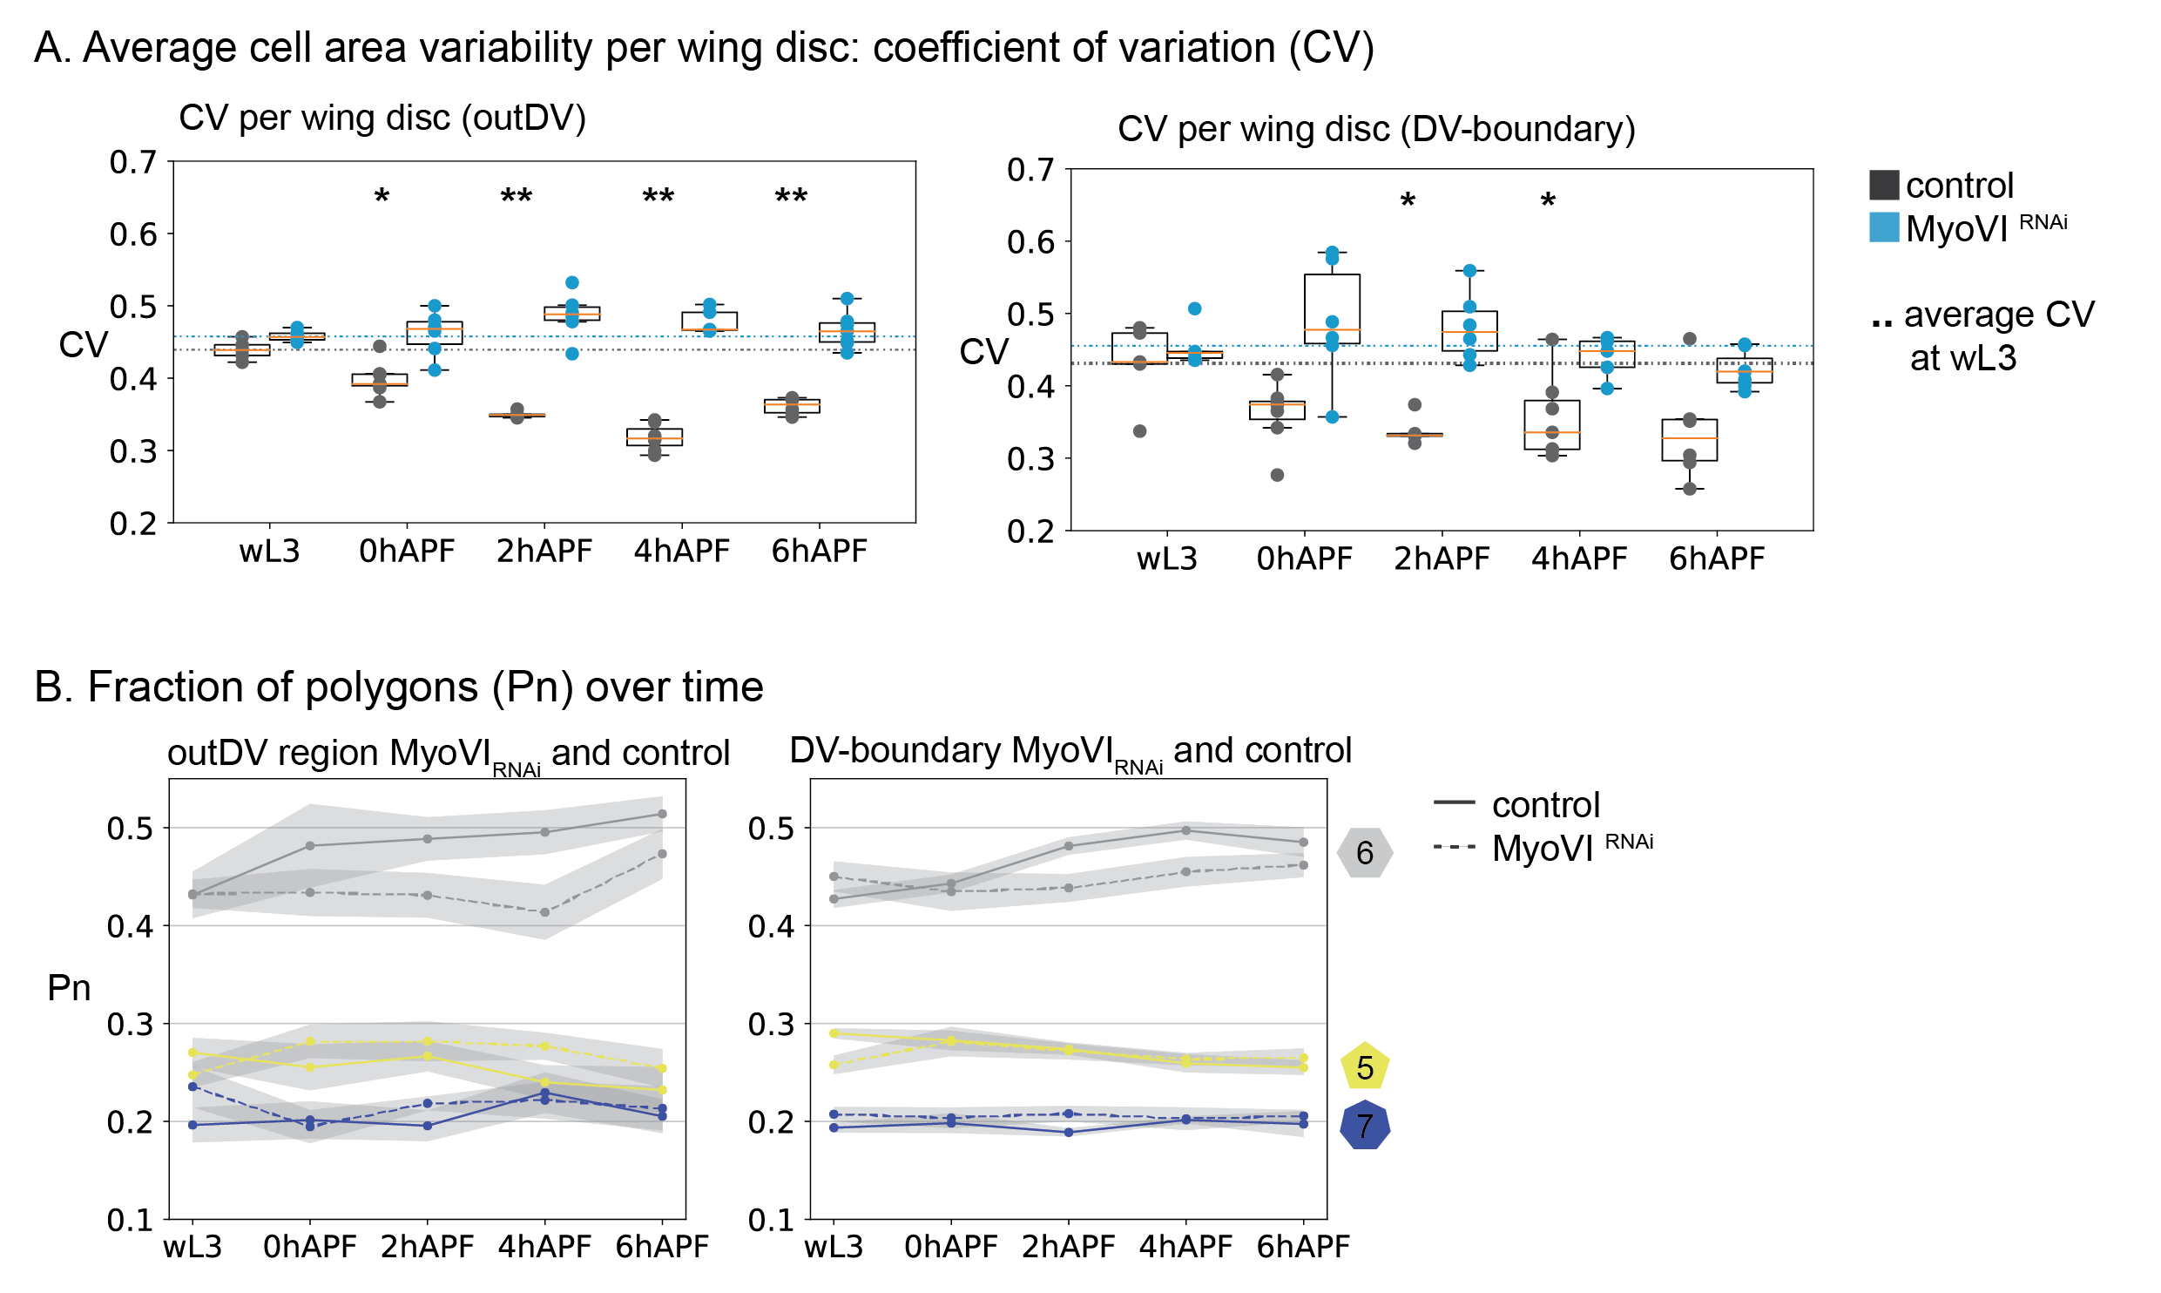

Figure ‑| packing geometry in MyoVIRNAi

Average cell area variability by coefficient of variation (CV) for outDV and the DV-boundary and MyoVIRNAi (blue) and wildtype (black) (A). Each datapoint is one wing disc, boxplots show the median in orange, box shows upper and lower quartile values, whiskers extend 1.5 beyond upper and lower quartile. Dotted line shows mean CV for wl3 stage for each genotype. Asterisks show statistical significance for each timepoint as compared to wL3 of the same genotype (Mann‑Whitney U, two-sided, method=exact, **: **: 1.00e-03 < p <= 1.00e-02, *: 1.00e-02 < p <= 5.00e-02. No asterisk: 5.00e-02 < p) (A). Fraction of polygonal cell shapes over evagination (B) Comparing the fraction of hexagons, pentagons and heptagons between wildtype (solid line) and MyoVIRNAi (dashed line) for outDV and DV-boundary. Shaded regions indicate the 95% confidence interval of the mean over all discs per developmental stage (B) colors correspond to polygon classes.

### Summary:Perturbation of cell and tissue shape using MyosinVI RNAi

Finish THIS

Taken together, our results indicate that MyosinVI deficient wing disc are most affected on their cell area dynamics and topological changes.

As we have seen in the wildtype, cell volume increases only a little during eversion, thus cell area expansion is coupled with cell height decrease and changes in 3D cell shape and aspect ratio. We find that in MyosinVI knockdown discs, cell volume changes are more dramatic over time. This effect is most pronounced at the end of evagination (4 hAPF).

In the outDV region, cell area changes resemble the changes in wildtype by the end of eversion. Yet the temporal dynamics are different: At the first step, from wL3 to 0 hAPF, we do not observe an area increase. Anisotropic cell area increase is then achieved at 2 and 4 hAPF, while at the same time cell volume increases. Simultaneously, in the DV‑boundary, cell areas fail to increase and cell volume decreases slightly. Cell rearrangements in that region are consistently lower over all stages and cells do not elongate as much in 2 and 4 hAPF wing discs.

Another interesting observation are cell area and volume changes from 4-6 hAPF. At this transition the tissue undergoes an increase in curvature at the DV‑boundary, leading to an outwards movement of the tissue margin in MyoVIRNAi. This as accompanied with an increase in DV‑boundary cell area and volume and a decrease in outDV cell area and volume. At the same time, we do not observe rearrangements and cell are more elongated along the DV than in wildtype. This is in contrast to the wildtype where area expansion is homogeneous throughout the tissue, cell elongation profiles resolve and rearrangements contribute to tissue‑expansion.

To be included:

## cell division/ rearrangements in live imaging?

The role of cell divisions for eversion:

So far we have considered cell divisions as negligible although they are included in topological changes we do not consider a significant cell number increase (or decrease by death). This is motivated by work showing that cell divisions occur rarely and give rise to future neuronal progenitors and thus likely do not fulfill a role for net tissue growth.

We confirm those observations:

* AB stainings!
* How long does PH3 stain?

We employed a live imaging approach

Can visually detect cell division in wt and myoVI

Observe eversion in cdc2ts flies.

## a role for ECM in eversion

light sheet

EM

Wing ultrastructure

The opening of the folds during eversion